Braywood CE First School The Acorn Nursery RE Topics
‘Aspire, Learn, Achieve’
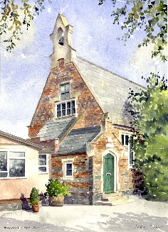

‘From tiny acorns, mighty oak trees grow, watered and nurtured by God’

Term 1 – Autumn 1 | Harvest  What can we learn from Stories about Jesus
Term 2 – Autumn 2 | Birthday of Guru Nanak  Hanukah  Diwali  The Christmas story. What is Christmas? Why do we celebrate Christmas?
Term 3 – Spring 1 | Epiphany  Chinese New Year  What can we learn from The Old Testament stories
Term 4 – Spring 2 | Lent  The Easter Story. What is Easter? Why do we celebrate Easter?
Term 5 – Summer 1 | More Stories about Jesus
Term 6 – Summer 2 | Creation – Our Wonderful world  Eid

