Curriculum map for Whole School
 | Topic  including.... | Science | ICT | History/ Geography | Art/DT | PE | Music | RSE & PSHE | RE | Extra-Curricular | English
Year 1  Term 1 | Secrets | Parts of Animals including Humans  Visit from a nurse  Nocturnal animals and their lives in the dark  Visit a real owl | Safe on the Internet  SMART and safe learners  Introduction to modeling  Play robots through mechanical me | Places people and the past,  Places in UK Barnaby Bear visits  Where animals live?  Endangered species | All about Me  Draw and sculpt ourselves e.g. ssilhouette, camera, black/ white, woodwork & stick people  Portraits by Artists | Gymnastics  Flight, bouncing, jumping and landing  Work with WSP and PE groupings  Whole school PE tournament | Singing  Harvest songs  Exploring Sounds  Sing songs in different languages | SEAL - New Beginning  Keeping staying Safe  &  Keeping staying Healthy  Computer Safety | Ways of learning Christianity  Visit to Church at Harvest  Writing prayers | Forest experience at Braywick Park  Harvest Festival  Visit to the Theatre | Wonderful Night Sky  Transition Unit  Meet Me
Year 1  Term 2 | Let’s Celebrate | Changing seasons and weather  Light, dark  Space, starts, etc | Pictograms  On a variety of medium  Communication and using text  Link to non-fiction work | Where celebrations take place and how have they changed over time.  Birthdays, weddings, | Draw and sculpt religious artifacts using clay  Pictures of Night Sky | Games  Throwing, catching and aiming  Work with WSP and PE groupings | Exploring duration  Listening to music for celebrations e.g. wedding march, Handel’s ‘fireworks’ | SEAL - Getting on and falling out  Relationship Feelings & Emotions  Bullying | Judaism  Celebration of the past including celebrations from other cultures | Visit to  All Saints Church  to practically share 4 different celebrations  Nativity | Wonderful Night Sky  Links to light festivals, fireworks night etc.
Year 1  Term 3 & 4 | Time Detectives  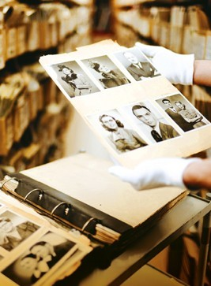 | Materials – Identify and Compare Material Properties | Using a Word Bank  Understand Instructions | Discover the Past  Investigate the past  Visit  Milestones Museum & Eton College | Using materials in Art/ textiles  Structures  Freestanding structures, sliders and levers | Windsor Dance Show  Gym –  Games – throwing and catching | Explore pulse and Rhythm  Using materials  Exploring pitch | SEAL - Going for Goals  &  Good to ne Me  RSE  Being Responsible | Learning about believing  Drama and Moral stories | Easter Concert  PE tournament  Pupil Parliament | Wolf’s Tale  Fairy stories and creative writing
Year 1 Term5 & 6 | My Wonderful World | Growing Plants  Plants and Animals in their environment | Information around us  Using the Roamer & Beebots | Our World  Locate and investigate local features incl simple fieldwork  Use Vegetable Plot | Sketching and still life  Famous artists  Cookery prepare foods using skills | Multi-skills, Athletics and Sports Day  Whole school PE tournament | Naming sounds  Exploring instruments and symbols including songs about our world | SEAL Relationship  Change  RSE  Money Matters | Sharing Faiths  Drama and moral stories | Trip to farm to see penguins Look Out or local area  Summer Fair | Ice Journey to Antarctica  Fiction and non-fiction work  Poems about outside world.
 | Topic  including.... | Science | ICT | History/ Geography | Art/DT | PE | Music | RSE & PSHE | RE | Extra-Curricular | English
Year 2  Term 1 | Great Explores | Understand more about Plants  Visit from a gardener  Plant our own seeds and describe what they need to survive.  Vegetable Plot | Safe on the Internet  SMART and safe learners  Reminder of the basics of word processing | Holidays  Explore differences between holidays in the past and present and the differences in locations. | All about Me  Natural world sculptures incl. freestanding  Design a garden  Still life pictures using plants | Gymnastics  Parts high pars low  Work with WSP and PE groupings  Whole school PE tournament | Exploring Sounds  Long and short – exploring duration  Singing  Harvest songs | SEAL - New Beginning  Keeping staying Safe  &  Keeping staying Healthy  Computer Safety | Ways of learning Christianity  Visit to Church at Harvest  Writing prayers | Forest experience at Windsor Great Park  Harvest Festival  Visit to the Theatre | Great Explorers  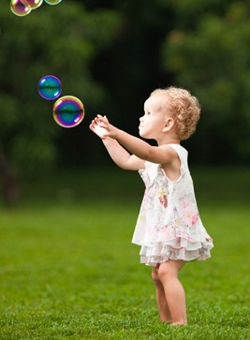  Transition Unit  Summer Holidays
Year 2  Term 2 | Celebrate - It’s great to be Alive | Animals including humans  Animals, off spring growing and our basic needs for health | Using technology to create, store and retrieve digital data  Link to different religions | Recognise and give simple accounts of core beliefs  Symbols, rituals and artifacts with visits from parents and speakers | Draw and sculpt religious artifacts using clay  Replicate diva lamps, common symbols | Games  Throwing, catching and aiming  Work with WSP and PE groupings | Exploring duration  Listening to music for celebrations e.g. wedding march, Handel’s ‘fireworks’ | SEAL - Getting on and falling out  Relationship Feelings & Emotions  Bullying | Judaism and Islamism  Celebration of the past including celebrations from other cultures | Visit to  St Michaels’ Church  to practically share 4 different celebrations  Nativity | Religious texts and stories  Links to pupils’ religions
Year 2  Term 3 & 4 | The Magic Toymaker | Materials – Identify and Compare Material Properties  Explore the suitability of everyday materials | Using a Word Bank  Understand Instructions  Using directional language and car robots | Toys - Past & Present  Investigate how toys have changed e.g. different materials  Reading Museum | Making a toy car  Wheels & Axils  Create and decorate car using cardboard, wood & paint | Gym – twist, turn & sequence  Games – making rules | Mainly pitch  Using Victorian toys as link  Exploring melodies and scales | SEAL - Going for Goals  &  Good to ne Me  RSE  Being Responsible | Learning about believing  Drama and Moral stories | Easter Concert  PE tournament  Pupil Parliament | Jack and the Beanstalk stories and creative writing
Year 2 Term5 & 6 | Hidden Homes & Habitats 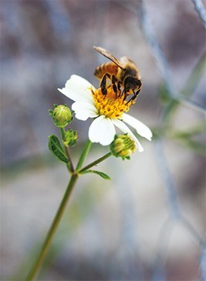 | Habitats  Differences between living, dead and inanimate.  Identify habitats and food chains | Research using the Internet  Create and understand Algorithms | Our World  Locate and investigate local features incl simple fieldwork, orienteering etc | Art using textiles  Printing, pattern & form  Cookery prepare foods using skills | Tennis, Athletics and Sports Day  Whole school PE tournament | Naming sounds  Exploring instruments and symbols including songs about our world | SEAL Relationship  Change  RSE  Money Matters | Sharing Faiths  Drama and moral stories | Trip to Look Out for Science  Habitats around school  Summer Fair | Writing specific tasks  Fiction and non-fiction work for SATS
 | Topic  including.... | Science | ICT | History/ Geography | Art/DT | PE | Music | RSE & PSHE | RE | Extra-Curricular | French English
Year 3  Term 1 | Celebrations – where I fit into my world | Animals including humans  Skeletons, muscle and nutrients  Understanding more about your body and how to stay healthy | Safe on the Internet  SMART and safe learners  Remember the basics e.g. word processing | Develop Religious Character  Explore differences and history of Judaism, Christianity, Sikhism and Islam | Religious Artifacts  Looking at religious buildings, artifacts and symbols.  Prepare healthy foods together. | Invasion Games  Throwing catching - Tag Rugby, Bench ball  Work with WSP and PE groupings  Whole school tournament | Listening to Religious Music  Healthy Food Rap & Harvest songs  Y3 learn to play instrument | SEAL - New Beginning  Keeping staying Safe  &  Keeping staying Healthy  Computer Safety | Religious Diversity Ways of learning and comparing a range of religions  Visit to Bray Church at Harvest | Forest experience at Windsor Great Park  Harvest Festival  Visit to the Gurdwara & Temple | Religious stories and prayers  Transition Unit  RWI Grey Unit
Year 3  Term 2 | Romans - Veni Vidi Vici  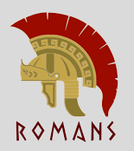 | Light and Shadows  Forces and Magnets  Investigate these simple scientific forces | Using Search technology wisely  Link to investigate Roman life. | Romans  Famous Roman architecture, Pompeii, Art, inventions, and way of life. | Roman Art  Recreate Roman Art, Mosaics, with textiles and sewing shills  Weapons catapult & Pully | Games  Throwing, catching and aiming  Work with WSP and PE groupings | Exploring rhythmic patters  Learning music for Christmas Concert | SEAL - Getting on and falling out  Relationship Feelings & Emotions  Bullying | Christianity  What type of world did Jesus want? What happened with Romans? | Visit to  Ufton Court to enact life of Romans  Nativity in Church | Legends including Romans  Links to topic including newspaper accounts
Year 3  Term 3 & 4 | Local Study – A World of Difference  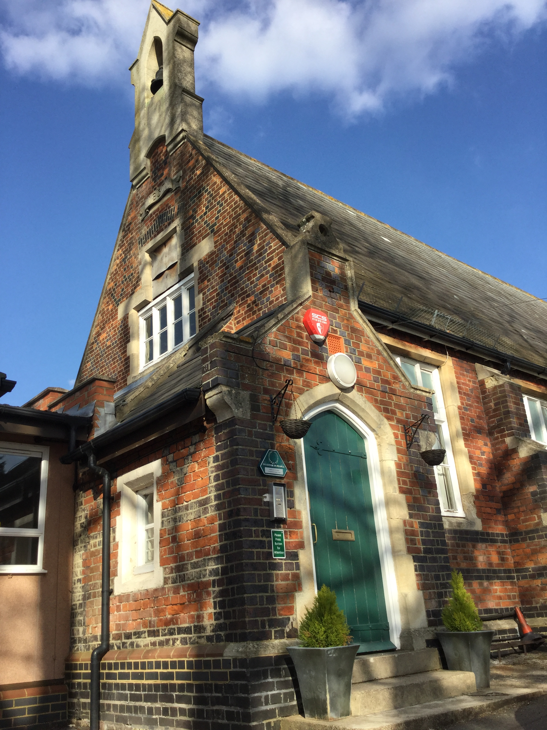 | Pars of Plants  Identify and describe parts and uses of the parts of a plant  Use the Vegetable plot | Use logical reasoning to explain simple algorithms  Write, debug programme  Google Maps | Braywood past and present  Investigate what life would be like in Victorian times | Life studies and still life  Examine plants around our school  Photo-montage of Braywood | Orienteering  Linked to local study  Rounders– striking and fielding | Wider Opportunities  Steel drums led by Berkshire Maestros  Exploring melodies and scales | SEAL - Going for Goals  &  Good to ne Me  RSE  Being Responsible | Learning about believing  Religious aspect of learning in a C of E school | Easter Concert  Victorian Day  Visit to Kidzania related to jobs / careers | Big Write Adventure  Write about life in Victorian times  My job
Year 3  Term5 & 6 | Our Active Planet | Rocks and Soils  Compare and group different types of rocks.  Making active, erupting volcano | Research using the Internet  Word process topic questions and finding answers | Volcanoes & Earthquakes  Locate volcanic areas of the word. Recognise fossils & link to Pompeii | Art using textiles  Printing, pattern & form  Create active volcano that erupts. | Cricket, Athletics and Sports Day  Whole school PE tournament | Sound / colours  Exploring theme of water cycle  Summer Concert on stage | SEAL Relationship  Change  RSE  Money Matters | Sharing Faiths  Drama and moral stories | Summer Fair  Trip  Bring bike or scooter into school Road Safety talk | Poetry and Non- Fiction  Poems about volcanoes, newspaper reviews
 | Topic  including.... | Science | ICT | History/ Geography | Art/DT | PE | Music | RSE & PSHE | RE | Extra-Curricular | French English
Year 4  Term 1 | Brainwave – How do I learn?  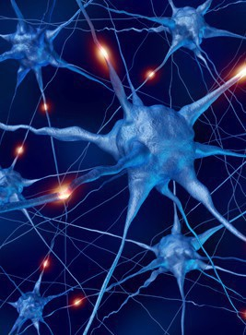 | Animals including humans – food chains, digestive system and teeth.  Understanding more about your body and how to stay healthy | Safe on the Internet  SMART and safe learners  Remember the basics e.g. word processing | Understanding more about the brain and how we learn.  Developing positive mindset to maintain positive learning skills. | Accurate drawings our anatomy  Looking at the various parts f the body.  Prepare healthy foods together. | Invasion Games  Throwing catching - Tag Rugby, Netball  Work with WSP and PE groupings  Whole school tournament | Rhythmic patterns on percussion  Practice for Harvest  Training for becoming Music leaders & WUSU leaders | SEAL - New Beginning  Keeping staying Safe  &  Keeping staying Healthy  Computer Safety | Religious Character  Prepare for becoming a Collective Worship leader with Revd Ainsley  Compare 4 key religions with focus on Sikhism | Forest experience at Longridge  Harvest Festival  Singing for Bray Senior citizens | 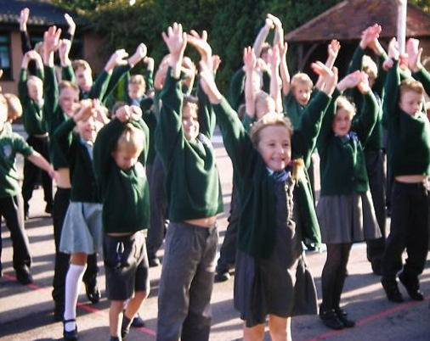  Transition Unit  Leadership on music, CW, sport, EYFS buddies,
Year 4  Term 2 | Egyptians Rule OK!  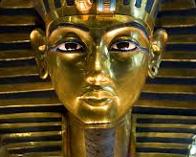 | Electricity  Investigate these simple electrical circuits, switches, buzzers etc.  Design Xmas decoration | Using Search technology  Data Program using Scratch | Egyptians  Famous Egyptian pyramids, Art, inventions, and way of life.  Compare light then and now | Egyptian Art & DT  Recreate Egyptian Art patterns with textiles and sewing shills Create your own tomb wall. | Dance – theme Egyptians  Games – hockey  Work with WSP and PE groupings | Explore composing & songs  Learning music for Egyptians & Christmas Concert | SEAL - Getting on and falling out  Relationship Feelings & Emotions  Bullying | Christianity  What is the Trinity?  Why was light important in religions past and present? | Visit to  Ufton Court  Visit Eton College  Lead the Nativity in Church | Egyptian life  Links to topic including descriptive accounts
Year 4  Term 3 & 4 | I love where I live – Windsor  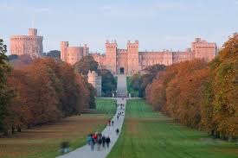 | Sounds  Identify how sounds are made, how sound travels and changes through pitch, volume etc.  Sounds of nature. | Use logical reasoning to explain simple algorithms  Write, debug program  Google Maps | Braywood past and present  Investigate what life would be like in Victorian times | Life studies and still life  Sketches of the local area.  Visit to Fifield with guided tour | Orienteering  Linked to local study  Gym – balance, roll & sequences | Instruments in the orchestra  Steel drums led by Berkshire Maestros  Exploring melodies and scales | SEAL - Going for Goals  &  Good to ne Me  RSE  Being Responsible | Learning about believing  Religious aspect of learning in a C of E school | Easter Concert  Tor of Fifield and talk about local History | Big Write Adventure  Write about life in our local area
Year 4  Term5 & 6 | Chocolate 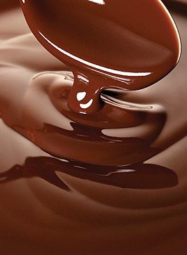 | States of Matter  Compare solid and melting chocolate  Water Cycle | Data collections & Information  Various collection of information | Chocolate  Where and how is chocolate manufactured and how does it find its way to the shops. | Packaging  Design packaging for chocolates and make a chocolate gift. | Cricket, Rounders & Golf Athletics and Sports Day  Whole school tournament | Sound / colours  Exploring theme of water cycle  Summer Concert on stage | SEAL Relationship  Change  RSE  Money Matters | Sharing Faiths  And questioning more about Christianity | Summer Fair  Leavers  PGL Trip  3 days and 2 evenings in activity camp | Poetry and Plays  Play for Summer Concert

