Braywood CE First School
Curriculum map for Foundation 1 (Nursery) Introductory Work Term 1
INTENT - Marvellous Me!
All about me, me and my family, farms and farm animals, Harvest, Autumn, Diwali, Bonfire night, Remembrance, disabilities, St Andrews Day, Christmas and Nativity, Money.
Be Safe  School Experience  Exploring our new surroundings  Using equipment safely  Cookery  Skills and Preparation  Bread  Watermelon Pizza | Enjoy and Achieve  Literacy  Pre-Phonics – Environmental sounds  All about Me  Maths  Colours, pre-counting/counting skills,  ,Seasons  Topic Assignment  Marvellous Me!  Expressive Art and Design and Music  Construction  Junk modelling  Playdough  Computing  Internet safety  How to use equipment safely | Be Healthy  Physical Education  How to use equipment safely  Co-ordination  Fine and Gross motor skills  Understanding the World  Pet Animals  Communication and Language  Marvellous Me Bag  (Show and tell)
Achieve Economic Well-being  Citizenship  Classroom rules and routines  Harvest Festival  Mums and Dads into School  Autumn  Saving money to give to Harvest |  | Make a Positive Contribution  PSHE  New Beginnings (SEAL)  Making friends  Being kind and playing nicely  Religious Education  What can we learn from Stories about Jesus  Music  Music unit - Exploring sounds and instruments

CONTINUOUS PROVISION TO INCLUDE SAND AND WATER ETC
Marvellous Me! |  |  | Foundation Stage 1
 | Literacy, Communication and Language | Mathematics | Understanding the World
 | - Develop their phonological awareness, so that they can: spot and suggest rhymes, count or clap syllables in a word, recognise words with the same initial sound, such as money and mother  - Understand the five key concepts about print: print has meaning, print can have different purposes, we read English text from left to right and from top to bottom, the names of the different parts of a book & page sequencing.  - Develop their pronunciation but may have problems saying: some sounds: r, j, th, ch, and sh multisyllabic words such as ‘pterodactyl’, ‘planetarium’ or ‘hippopotamus’ | - Talk about and identifies the patterns around them. For example: stripes on clothes, designs on rugs and wallpaper. Use informal language like ‘pointy’, ‘spotty’, ‘blobs’ etc.  - Extend and create ABAB patterns – stick, leaf, stick, leaf.  - Notice and correct an error in a repeating pattern.  - Make comparisons between objects relating to size, length, weight and capacity.  - Begin to describe a sequence of events, real or fictional, using words such as ‘first’, ‘then... | - Talk about members of their immediate family and community. Names and describe people who are familiar to them. Within a small group.  - Begin to make sense of their own life-story and family’s history.  - Talk about the differences between materials and changes they notice.

IMPLIMENTATION - Subject Objective | IMPACT - Assessment
Personal, Social & Emotional Development | Beginning | Secure | Mastery
- Select and use activities and resources, with help when needed. This helps them to achieve a goal they have chosen, or one which is suggested to them.  - Increasingly follow rules, understanding why they are important.  - Remember rules without needing an adult to remind them. | Requires support to access resources. Shows basic understanding of class rules. | Needs encouragement to access resources. Shows an understanding of class rules. | Independently gathers resources from appropriate area. Understands & follows class rules, some of the time.
Physical Development
- Use a comfortable grip with good control when holding pens and pencils.  - Show a preference for a dominant hand.  - Use large-muscle movements to wave flags and streamers, paint and make marks.  - Managing basic hygiene and safety needs | Uses a comfortable grip with good control. Beginning to show a preference for a dominant hand | Able to hold a pencil comfortably and make letter like shapes. Uses a dominate hand. | Uses modified tripod grip.  Is able to form basic recognisable letters.
Expressive Arts & Design
- Join different materials and explore different textures.  - Explore different materials freely, to develop their ideas about how to use them and what to make.  - Develop their own ideas and then decide which materials to use to express them.  - Remember and sing entire songs. | Explore materials and develop ideas about how to join the, | Seeks help to select appropriate tools, objects, building and  malleable materials. | Uses various building materials Selects and uses various tools, objects, building and malleable materials.
ICT
- Operating simple technology such as toys  - To begin to understand that information can be retrieved from computers | Seeks help when turning on a computer. | Needs encouragement to turn on a computer. | Turns on a computer with support. Needs adult help to complete a simple program.
Religious education and world views
- To develop a growing sense of the child’s awareness of self, their own  community and their place within this. | Can name people who are special to them. | Talk about people who are special to them. Say what makes their family and friends special to them | Identify some of the qualities of a good friend. Recall and talk about stories of Jesus as a friend to others.

Braywood CE First School
Curriculum map for Foundation 1 (Nursery) Term 2
INTENT – Who goes woof?
Autumn, Diwali, Bonfire night, Remembrance, disabilities, St Andrew’s Day, Christmas and Nativity, Money.
Be Safe  School Experience  Exploring our new surroundings  Using equipment safely  Cookery  Skills and Preparation  Baking Bread  Making a sandwich  Gingerbread Man | Enjoy and Achieve  Literacy  Pre-Phonics – Environmental sounds  Dogs, Cats and other pets  Maths  Measurement, counting and shapes  Topic Assignment  Who goes woof?  (Pets & other animals on the Farm)  Expressive Art, Design and Music  Construction  Junk modelling  Playdough  Music unit - Exploring sounds and instruments  Computing  Interact white Boards  How to use equipment safely, inc. Computers | Be Healthy  Physical Education  Co-ordination  Fine and Gross motor skills  Spatial Awareness  Using hoops  Understanding the World  Pets  Diwali  Communication and Language  My Favourite pet  (Show and tell)
Achieve Economic Well-being  Citizenship  Diwali  Bonfire night  Remembrance Day  St Andrew’s Day  Christmas Fair  Saving money for the needy at Christmas and attend the Nativity concert |  | Make a Positive Contribution  PSHE  Getting on and falling out (SEAL)  Making friends  Being kind and playing nicely  Religious Education  Hanukah  Diwali  The Christmas story  What is Christmas? Why do we celebrate Christmas?

CONTINUOUS PROVISION TO INCLUDE SAND AND WATER
Who goes woof? |  |  | Foundation Stage 1
 | Literacy, Communication and Language | Mathematics | Understanding the World
 | - Develop their phonological awareness, so that they can: spot and suggest rhymes, count or clap syllables in a word, recognise words with the same initial sound, such as money and mother  - Understand the five key concepts about print: print has meaning, print can have different purposes, we read English text from left to right and from top to bottom, the names of the different parts of a book & page sequencing.  - Write some or all of their name.  - Develop their pronunciation but may have problems saying: some sounds: r, j, th, ch, and sh multisyllabic words such as ‘pterodactyl’, ‘planetarium’ or ‘hippopotamus’ | - Select shapes appropriately: flat surfaces for building, a triangular prism for a roof etc.  - Combine shapes to make new ones – an arch, a bigger triangle etc.  - Talk about and explore 2D and 3D shapes (for example, circles, rectangles, triangles and cuboids) using informal and mathematical language: ‘sides’, ‘corners’; ‘straight’, ‘flat’, ‘round’.  - Compare quantities using language: ‘more than’, ‘fewer than’.  - Make comparisons between objects relating to size, length, weight and capacity. | - Begin to understand the need to respect and care for the natural environment and all living things.  - Explore how things work.  - Talk about the differences between materials and changes they notice.

IMPLIMENTATION - Subject Objective | IMPACT - Assessment
Personal, Social & Emotional Development | Beginning | Secure | Mastery
- Become more outgoing with unfamiliar people, in the safe context of their setting.  - Show more confidence in new social situations.  - Play with one or more other children, extending and elaborating play ideas | Gaining in confidence when familiar adults are near by.  Beginning to form bonds with other children | Responds positively to a variety of familiar adults.  Shows affection towards other children & younger siblings. | Is more outgoing towards strangers & more confident in new social situations, although may be anxious at first. Forms a special friendship with another child
Physical Development
- Be increasingly independent as they get dressed and undressed, for example, putting coats on and doing up zips.  - Use large-muscle movements to wave flags and streamers, paint and make marks. | Able to put on shoes without fastening (may be wrong foot)  Can pull zips up and down, but unable to insert or separate shank | Takes off loose shirt when undone. Unzips coat. Can undo Velcro fasteners. | Pulls up trousers & zips already matched up.  Can undo some buttons. Puts arms into open coat when held up
Expressive Arts & design
- Join different materials and explore different textures.  - Explore different materials freely, to develop their ideas about how to use them and what to make.  - Develop their own ideas and then decide which materials to use to express them.  - Remember and sing entire songs. | Explore materials and develop ideas about how I might use them | Join junk modelling items  together and talk about what  they have made with them. | Enjoy exploring a wide range of ‘junk modelling’ and natural materials, making simple forms - building with 3D shapes
ICT
- Operating simple technology such as toys  - Understanding that information can be retrieved from computers | Needs encouragement to turn on a computer. | Turns on a computer with support. Needs adult help to complete a simple program. | Turns on a computer. Able to complete a simple program with encouragement.
Religious education and world views
- To begin to recognise that Christians believe God came to Earth in human form as Jesus to show that all people are precious and special to God | To start to understand that Christmas is the celebration of Jesus’ birth. | To recall the Christmas Story and with support the characters in it. To understand that Christmas is the celebration of Jesus’ birth. | Recall The Christmas Story and the characters within it. To understand that Christmas is the celebration of Jesus’ birth.

Braywood CE First School
Curriculum map for Foundation 1 (Nursery) Term 3
IMPACT - What can I be?
New year, New beginnings, targets, Winter, Healthy eating, Shops, colours and the rainbow, healthy living, exercise, the body, Chinese New Year, Pancake day, Lent
Be Safe  School Experience  Using equipment safely  Healthy Living  Cookery  Skills and Preparation  Frozen Banana people (Occupations) | Enjoy and Achieve  Literacy  Pre-Phonics – Environmental sounds  Occupations  Maths  Numbers, shapes and measurements - height  Topic Assignment  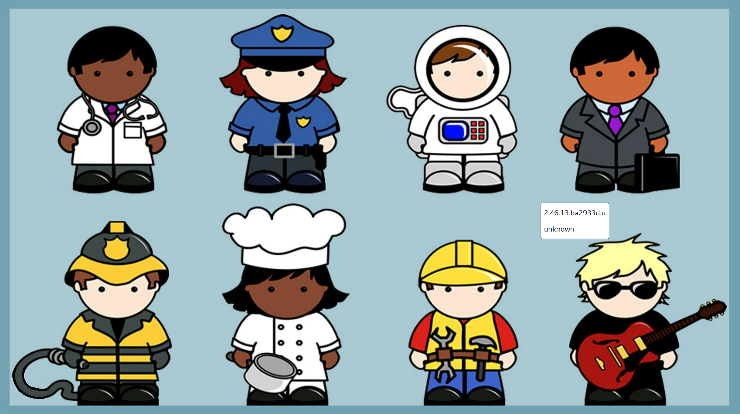  What can I be?  (Occupations)  Expressive Art and Design and Music  Construction  Playdough  Music unit - Exploring sounds and instruments  Computing  Interact white Boards  How to use equipment safely, inc. Computers | Be Healthy  Physical Education  Co-ordination  Fine and Gross motor skills  Ball skills  Understanding the World  Occupations  Communication and Language  What can I be?  (Show and tell – Dress up)
Achieve Economic Well-being  Citizenship  Chinese New Year  Pancake Day  Lent  Winter |  | Make a Positive Contribution  PSHE  Going for Goals (SEAL)  Making friends  Being kind and playing nicely  Religious Education  Epiphany  Chinese New Year  What can we learn from The Old Testament stories

CONTINUOUS PROVISION TO INCLUDE SAND AND WATER

What can I be? |  |  | Foundation Stage 1
 | Literacy, Communication and Language | Mathematics | Understanding the World
 | - Develop their phonological awareness, so that they can: spot and suggest rhymes, count or clap syllables in a word, recognise words with the same initial sound, such as money and mother  - Understand the five key concepts about print: print has meaning, print can have different purposes, we read English text from left to right and from top to bottom, the names of the different parts of a book & page sequencing.  - Use some of their print and letter knowledge in their early writing. For example: writing a pretend shopping list that starts at the top of the page; writing ‘m’ for mummy.  - Write some or all of their name.  - Enjoy listening to longer stories and can remember much of what happens.  - Use longer sentences of four to six words. | - Develop fast recognition of up to 3 objects, without having to count them individually (‘subitising’).  - Recite numbers past 5.  - Say one number for each item in order: 1,2,3,4,5.  - Know that the last number reached when counting a small set of objects tells you how many there are in total (‘cardinal principle’).  - Show ‘finger numbers’ up to 5.  - Link numerals and amounts: for example, showing the right number of objects to match the numeral, up to 5.  - Talk about and identifies the patterns around them. For example: stripes on clothes, designs on rugs and wallpaper. Use informal language like ‘pointy’, ‘spotty’, ‘blobs’ etc.  - Make comparisons between objects relating to size, length, weight and capacity. | - Show interest in different occupations.  - Explore how things work.  - Continue developing positive attitudes about the differences between people.  - Know that there are different countries in the world and talk about the differences they have experienced or seen in photos.

IMPLIMENTATION - Subject Objective | IMPACT - Assessment
Personal, Social & Emotional Development | Beginning | Secure | Mastery
- Develop appropriate ways of being assertive.  - Talk with others to solve conflicts.  - Be able to express a point of view and to debate when they disagree with an adult or a friend, using words as well as actions.  - Talk about their feelings using words like ‘happy’, ‘sad’, ‘angry’ or ‘worried’.  - Understand gradually how others might be feeling. | Beginning to talk with others to solve conflicts. Starting to be able to talk about their feelings using words like ‘happy’, ‘sad’, ‘angry’ or ‘worried’. | Shows concern towards others who are upset i.e. offers pats arm or back, offers cuddle etc. Talks about their feelings using words like ‘happy’, ‘sad’, ‘angry’ or ‘worried’ | Shows resilience and perseverance in the face of challenge. Can identify and moderate their own feelings socially and emotionally.
Physical Development
- Continue to develop their movement, balancing, riding (scooters, trikes and bikes) and ball skills.  - Use a comfortable grip with good control when holding pens and pencils.  - Show a preference for a dominant hand. | Can throw a ball underhand Kicks ball with one foot while swinging opposite arm | Throws ball underhand. Can catch a ball by chasing- does not necessarily respond to aerial ball. Bounces a large ball. Uses foot to tap static ball a small  Distance. Walks towards and kick a ball. | Catches a large ball between extended arms. Catches a large ball by bringing hands  in towards chest. Bounces and catch a large ball using 2  hands. Walks towards and kick a ball towards a target
Expressive Arts & design
- Listen with increased attention to sounds.  - Respond to what they have heard, expressing their thoughts and feelings.  - Play instruments with increasing control to express their feelings and ideas. | Listen with increased attention to sounds. Respond to the music and sounds that they hear, expressing their thoughts and feelings. | Perform poems, songs and rhymes as part of my class/group, Learning new songs and actions to  support teacher-led narration. | Listen attentively, move to and talk about music, expressing my feelings and responses.
ICT
- Complete a simple program on a computer using age-appropriate software.  - Children recognise that technology is in the home and school and can select and use technology for particular purposes. | Requires support to input commands using a mouse. Is able to use finger control to interact with a tablet (double tap, swipe) most of the time. | Requires support to input commands using a mouse some of the time. Is able to use finger control to interact with a tablet (double tap, swipe) | Input commands most of the time using a mouse to control a cursor and use the left click to select options OR use finger control to interact with a tablet (double tap, swipe)
Religious education and world views
- .To recognise that people may have special books.  - To recognise that many people learn about ways of living from books and  stories. | To start to identify some of their own feelings in the stories they hear. To start to recognise that we can learn from stories. | Identify some of their own feelings in the stories they hear. To start to understand that we can learn from stories. | Recognise some religious words, e.g. about God. To understand that we can learn from stories.

Braywood CE First School
Curriculum map for Foundation 1 (Nursery) Term 4
INTENT – What is in my Egg?
St. David’s Day, internet safety, Mother’s Day, St. Patrick’s Day, eggs, dinosaurs, Easter.
Be Safe  School Experience  Using equipment safely  Cookery  Skills and Preparation  Easter Tomb Biscuits | Enjoy and Achieve  Literacy  Pre-Phonics – Environmental sounds  Dinosaurs  World Book Day  Maths  Numbers and positional language  Topic Assignment  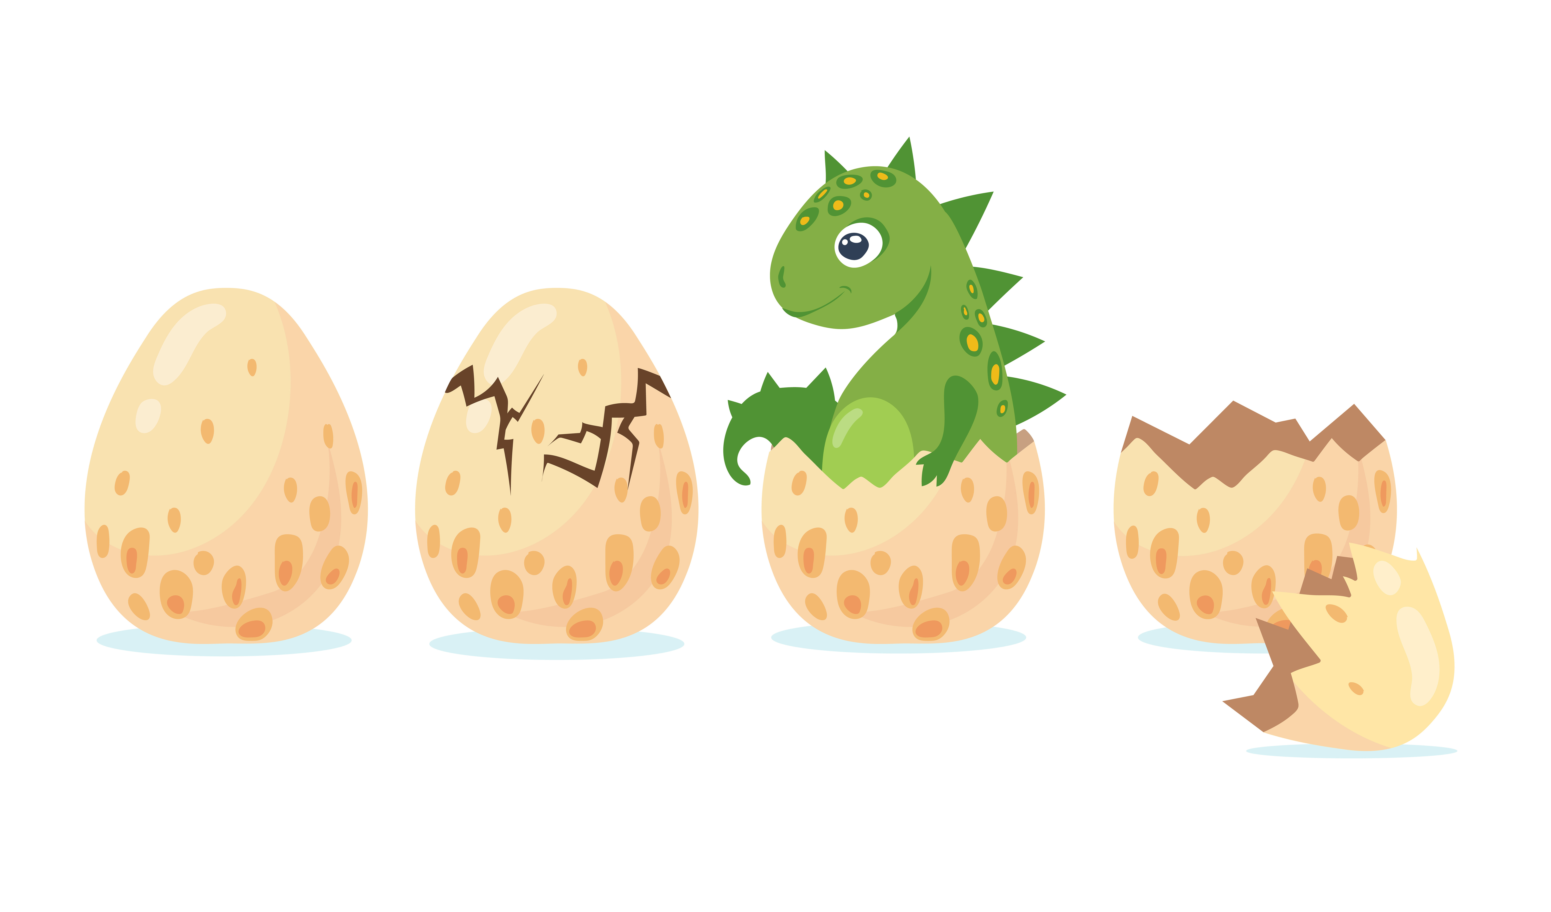  What is in my Egg?  (Dinosaurs and Ducklings)  Expressive Art and Design and Music  Construction  Singing  Playdough  Music unit - Exploring sounds and instruments  Computing  IWB  Beebots | Be Healthy  Physical Education  Co-ordination  Trim Trail  Climbing  Understanding the World  Healthy Living – Our Body  Past and Present  Dinosaurs/Creatures that hatch from eggs (CL)  Communication and Language  My Favourite Book  (Show and tell)
Achieve Economic Well-being  Citizenship  St. David’s Day  Mothering Sunday  Easter Music Concert and collection  Spring  Ducklings |  | Make a Positive Contribution  PSHE  Feels good to be me (SEAL)  Making friends  Being kind and playing nicely  Religious Education  Lent  The Easter Story  What is Easter? Why do we celebrate Easter?  Ramadan

CONTINUOUS PROVISION TO INCLUDE SAND AND WATER
What is in my Egg? (Dinosaurs and Ducklings) |  |  | Foundation Stage 1
 | Literacy, Communication and Language | Mathematics | Understanding the World
 | - Develop their phonological awareness, so that they can: spot and suggest rhymes, count or clap syllables in a word, recognise words with the same initial sound, such as money and mother  - Understand the five key concepts about print: print has meaning, print can have different purposes, we read English text from left to right and from top to bottom, the names of the different parts of a book & page sequencing.  - Use some of their print and letter knowledge in their early writing. For example: writing a pretend shopping list that starts at the top of the page; writing ‘m’ for mummy.  - Write some or all of their name.  - Enjoy listening to longer stories and can remember much of what happens.  - Use longer sentences of four to six words. | - Develop fast recognition of up to 3 objects, without having to count them individually (‘subitising’).  - Recite numbers past 5.  - Say one number for each item in order: 1,2,3,4,5.  - Know that the last number reached when counting a small set of objects tells you how many there are in total (‘cardinal principle’).  - Show ‘finger numbers’ up to 5.  - Link numerals and amounts: for example, showing the right number of objects to match the numeral, up to 5.  - Experiment with their own symbols and marks as well as numerals.  - Solve real world mathematical problems with numbers up to 5.  - Compare quantities using language: ‘more than’, ‘fewer than’.  - Understand position through words alone – for example, “The bag is under the table,” – with no pointing.  - Describe a familiar route.  - Discuss routes and locations, using words like ‘in front of’ and ‘behind’. | - Understand the key features of the life cycle of a plant and an animal.  - Use all their senses in hands-on exploration of natural materials.  - Explore collections of materials with similar and/or different properties.  - Talk about what they see, using a wide vocabulary.

IMPLIMENTATION - Subject Objective | IMPACT - Assessment
Personal, Social & Emotional Development | Beginning | Secure | Mastery
- Develop their sense of responsibility and membership of a community.  - Be able to express a point of view and to debate when they disagree with an adult or a friend, using words as well as actions. | Develop their sense of responsibility and membership of a community. Becoming more outgoing with unfamiliar people, in the safe context of their setting. Show more confidence in new social situations | Beginning to adjusts their behaviour according to the needs of others.. Starting to follow multi-level instructions accurately some of the time even. Is often able to play cooperatively and wait their turn. | Can adjusts their behaviour according to the needs of others.. Able to follow multi-level instructions accurately some of the time even. Is able to play cooperatively and wait their turn, some of the time.
Physical Development
- Go up steps and stairs, or climb up apparatus, using alternate feet.  - Observing the effects of physical activity | Climbs and uses climbing equipment when an adult is watching. Goes up steps and stairs placing both feet on one step at a time | Climbs and uses climbing equipment when an adult is nearby. Climbs up apparatus, using two feet - Climbs above their own head height | Climbs upstairs using alternative feet - Climbs up apparatus using two feet. Can jump forward about 60 cm (2 feet).
Expressive Arts & design
- Join different materials and explore different textures.  - Explore different materials freely, to develop their ideas about how to use them and what to make. | Holds scissors, often with both hands, learning to open and close the blades - Opens/closes blades (not ready to use them on paper yet) - Starts snipping paper (not moving forward with the scissors but making small snips) | Requires support to access resources. Struggles with scissor control. Snips paper moving forward - Uses helping hand to hold and help to guide the paper (non-dominant hand) - Cuts curved line with some accuracy. | Needs encouragement to access the appropriate resources. Cuts circle shape with increasing accuracy. Cuts square shape
ICT
- Completes a simple program on a computer.  - Uses ICT hardware to interact with age-appropriate computer software.  - Children recognise that a range of technology is used in places such as homes and schools. They select and use technology. | Is only able input commands using the space bar, backspace, enter, letters and numbers on a keyboard on any device (including on a tablet) when working 1 to 1 with another child or adult. | Requires support to input commands using the space bar, backspace, enter, letters and numbers on a keyboard on any device (including on a tablet). | Input commands using the space bar, backspace, enter, letters and numbers on a keyboard on any device (including on a tablet).
Religious education and world views
- To begin to recognise that Christians remember Jesus’ last week at Easter.  - To begin to recognise that Christians try to show love to others | To identify signs of new life in nature. To start to recognise some Christian symbols. | Talk about ideas of new life in nature. Recognise some symbols Christians  use during Holy Week, e.g. palm leaves, cross, eggs, etc., and make  connections with signs of new life in nature | Recognise and retell stories connected with celebration of Easter. Say why Easter is a special time for Christians

Braywood CE First School
Curriculum map for Foundation 1 (Nursery) Term 5
INTENT - Exploring our World!
Changes, St. Georges Day, dragons, plants and life-cycle, mini-beasts, maps and directions, textures
Be Safe  School Experience  Using equipment safely  Cookery  Skills and Preparation  ‘Fish’ biscuits | Enjoy and Achieve  Literacy  Read Write Inc.  Fish and other sea creatures  Maths  Numbers, shapes, capacity and time  Topic Assignment  Splish, splash, splosh – what lives in water?  Expressive Art and Design and Music  Music unit - Exploring sounds and instruments  Computing  IWB  Computers  Beebots | Be Healthy  Physical Education  Co-ordination  Balance  Understanding the World  Plants  Sea Creatures  Communication and Language  What’s inside my pond?  (Show and tell – Design a pond)
Achieve Economic Well-being  Citizenship  St. George’s Day  Summer Fair  Summer |  | Make a Positive Contribution  PSHE  Relationships (SEAL)  Changes (SEAL)  Religious Education  More Stories about Jesus

CONTINUOUS PROVISION TO INCLUDE SAND AND WATER
Splish, splash, splosh – what lives in water? |  |  | Foundation Stage 1
 | Literacy, Communication and Language | Mathematics | Understanding the World
 | - Read individual letters by saying the sounds for them.  - Use some of their print and letter knowledge in their early writing. For example: writing a pretend shopping list that starts at the top of the page; writing ‘m’ for mummy.  - Write some or all of their name.  - Write some letters accurately.  - Enjoy listening to longer stories and can remember much of what happens.  - Pay attention to more than one thing at a time, which can be difficult.  - Use longer sentences of four to six words. | - Develop fast recognition of up to 3 objects, without having to count them individually (‘subitising’).  - Recite numbers past 5.  - Say one number for each item in order: 1,2,3,4,5.  - Know that the last number reached when counting a small set of objects tells you how many there are in total (‘cardinal principle’).  - Show ‘finger numbers’ up to 5.  - Link numerals and amounts: for example, showing the right number of objects to match the numeral, up to 5.  - Experiment with their own symbols and marks as well as numerals.  - Solve real world mathematical problems with numbers up to 5.  - Compare quantities using language: ‘more than’, ‘fewer than’.  - Talk about and explore 2D and 3D shapes (for example, circles, rectangles, triangles and cuboids) using informal and mathematical language: ‘sides’, ‘corners’; ‘straight’, ‘flat’, ‘round’.  - Select shapes appropriately: flat surfaces for building, a triangular prism for a roof etc.  - Combine shapes to make new ones – an arch, a bigger triangle etc.  - Make comparisons between objects relating to size, length, weight and capacity.  - Begin to describe a sequence of events, real or fictional, using words such as ‘first’, ‘then... | - Begin to understand the need to respect and care for the natural environment and all living things.  - Use all their senses in hands-on exploration of natural materials.  - Explore collections of materials with similar and/or different properties.  - Talk about what they see, using a wide vocabulary.

IMPLIMENTATION - Subject Objective | IMPACT - Assessment
Personal, Social & Emotional Development | Beginning | Secure | Mastery
- Be increasingly independent in meeting their own care needs, e.g. brushing teeth, using the toilet, washing and drying their hands thoroughly.  - Make healthy choices about food, drink, activity and toothbrushing. | Able to find solutions to conflicts and rivalries  Beginning to remember and follow rules with some understanding.  To be increasingly independent in meeting their own care needs | Remember rules without needing an adult to remind them, understanding why they are important.  Show resilience and perseverance in the face of challenge. | Confident to try new activities, most of the time, showing independence, resilience and perseverance in the face of challenge.  Able to explain the reasons for most rules. Starting to understand the  importance of a healthy life style. Recognise how exercise makes them feel
Physical Development
- Collaborate with others to manage large items, such as moving a long plank safely, carrying large hollow blocks.  - Skip, hop, stand on one leg and hold a pose for a game like musical statues | Stands on tiptoes. Stands on one foot for 2 seconds. Walks along a chalk line. Walks along a low, wide balance beam, sometimes  needing to balance again an  adult  . | Walks along a low, wide  balance beam independently. Holds a controlled static  balance on one leg | Walks along a low narrow  balance
Expressive Arts & design
- Create closed shapes with continuous lines, and begin to use these shapes to represent objects.  - Draw with increasing complexity and detail, such as representing a face with a circle and including details.  - Use drawing to represent ideas like movement or loud noises.  - Show different emotions in their drawings and paintings, like happiness, sadness, fear etc. | Draw with increasing complexity and detail e.g. representing a face with a circle and adding some details. Shows different emotions in drawings. Create closed shapes with continuous lines and use these shapes to represent objects | Draws potato people (no neck or body) Demonstrates more control - Draws with detail (bodies with sausage limbs and additional features) - Draws bodies of an appropriate size for what they’re drawing | Beginning to draw self-portraits, landscapes and buildings/cityscape. Draws objects and creatures in proportion to each  other (e.g. elephant is bigger than a dog) Spends a sustained amount of time on one product.
ICT
- Completes a simple program on a computer.  - Uses ICT hardware to interact with age-appropriate computer software.  - Children recognise that a range of technology is used in places such as homes and schools.  - They select and use technology for particular purposes. | To programme the Beebot, needs 1 to 1 support of another child or adult. | Needs support to programme the Beebot | Independently programme the Beebot to complete an instruction.
Religious education and world views
- To recognise that people may have special books.  - To recognise that many people learn about ways of living from books and  - stories. | To start to identify some of their own feelings in the stories they hear. To start to recognise that we can learn from stories. | Identify some of their own feelings in the stories they hear. To show understanding that we can learn from stories. | Recognise some religious words, e.g. about God. To understand that we can learn from stories.

Braywood CE First School
Curriculum map for Foundation 1 (Nursery) Term 6
INTENT - Splish, splash, splosh – what lives in water?
Technology, occupations, Father’s Day, Summer, Sea and beaches, capacity, float or sink, recycling, Eid, transitions.
Be Safe  School Experience  Using equipment safely  Cookery  Skills and Preparation  Salad Fish | Enjoy and Achieve  Literacy  Read Write Inc.  Fish and other sea creatures  Maths  Number s and measurement - weight  Topic Assignment  Splish, splash, splosh – what lives in water?  Expressive Art and Design and Music  Music unit - Exploring sounds and instruments  Computing  IWB  Computers  Beebots | Be Healthy  Physical Education  Sport’s Day  Understanding the World  Plants  Sea Creatures  Recycling  Communication and Language  What’s inside my Bucket?  (Show and tell – Favourite Sea Creature)  What I have enjoyed in FS 1 and am looking forward to in FS 2.
Achieve Economic Well-being  Citizenship  Father’s Day  Sport’s Day  Transition to FS 2 |  | Make a Positive Contribution  PSHE  Saying No to Bullying (SEAL)  Changes (SEAL)  Religious Education  Creation – Our Wonderful world  Eid

CONTINUOUS PROVISION TO INCLUDE SAND AND WATER
Splish, splash, splosh – what lives in water? |  |  | Foundation Stage 1
 | Literacy, Communication and Language | Mathematics | Understanding the World
 | - Read individual letters by saying the sounds for them.  - Use some of their print and letter knowledge in their early writing. For example: writing a pretend shopping list that starts at the top of the page; writing ‘m’ for mummy.  - Write some or all of their name.  - Write some letters accurately.  - Enjoy listening to longer stories and can remember much of what happens.  - Pay attention to more than one thing at a time, which can be difficult.  - Use longer sentences of four to six words. | - Develop fast recognition of up to 3 objects, without having to count them individually (‘subitising’).  - Recite numbers past 5.  - Say one number for each item in order: 1,2,3,4,5.  - Know that the last number reached when counting a small set of objects tells you how many there are in total (‘cardinal principle’).  - Show ‘finger numbers’ up to 5.  - Link numerals and amounts: for example, showing the right number of objects to match the numeral, up to 5.  - Experiment with their own symbols and marks as well as numerals.  - Solve real world mathematical problems with numbers up to 5.  - Compare quantities using language: ‘more than’, ‘fewer than’.  - Make comparisons between objects relating to size, length, weight and capacity. | - Begin to understand the need to respect and care for the natural environment and all living things.  - Use all their senses in hands-on exploration of natural materials.  - Explore collections of materials with similar and/or different properties.  - Talk about what they see, using a wide vocabulary.

IMPLIMENTATION - Subject Objective | IMPACT - Assessment
Personal, Social & Emotional Development | Beginning | Secure | Mastery
- Show increasing confidence and resilience when faced with a new situation. (Moving on to FS 2)  - Continue to develop previously ‘taught’ areas.  - Be able to express a point of view and to debate when they disagree with an adult or a friend, using words as well as actions. | Able to focus during short whole class activities.  Can use appropriate ways of being assertive (Stop, I don’t like it.) without prompting | Able to focus during whole class activities.  Can use appropriate ways of being assertive (Stop, I don’t like it.) without prompting most of the time. | To maintain focus during  extended whole class teaching.  Able to use appropriate ways of being assertive (Stop, I don’t like it.) independently.
Physical Development
- Match their developing physical skills to tasks and activities in the setting. For example, they decide whether to crawl, walk or run across a plank, depending on its length and width.  - Use large-muscle movements to wave flags and streamers, paint and make marks. | Can moves around obstacles. Movement is stilled and jerky. | Developing a fluid motion of movement with control and  Grace, while running around obstacles. | Can moves around obstacles with a fluid motion.
Expressive Arts & design
- Sing the pitch of a tone sung by another person (‘pitch match’).  - Sing the melodic shape (moving melody, such as up and down, down and up) of familiar songs.  - Create their own songs or improvise a song around one they know.  - Remember and sing entire songs.  - Sing a large repertoire of songs. | Remember and sing entire nursery rhymes. Sing the pitch of a tone sung by another person (pitch matching) with music. Create or improvise a song around one that they know (after this has been modelled) | Know a wide variety of well-known nursery rhymes and can learn some new songs as well. | Sing in a group or on my own with an increasing ability to match the pitch and follow the melody
ICT
- Children recognise that a range of technology is used in places such as homes and schools. | Is beginning to understand what a computer is and that they are used at home and school. | Starting to recognise technology that is used at home and in school. Understands what a computer is and the different uses of computers i.e. Learning, communicating, finding information, playing games etc. | Recognise technology that is used at home and in school.. Understand what a computer is and the different uses of computers i.e. Learning, communicating, finding information, playing games etc.
Religious education and world views
- To recognise that Christians believe God is the creator of the universe and that God made our wonderful world so we should look after it.  - To understand that The word God is a name. | To talk simply about the creation story. | Talk about the creation bible story and remember part of it. Think, talk and ask questions about living in an amazing world. | Know that Christians praise God for his amazing creation and design.  Recognise that ‘Creation’ is the beginning of the ‘big story’ of the Bible.

