Term 1 | Topic title | Maths | English
Week 1 | Marvellous Me | Investigating colour | Settling in and confidence  Nursery Rhymnes …. | 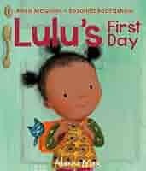
Week 2 | All About Me | Patterns and colour | Vocabulary to describe a child including their name | 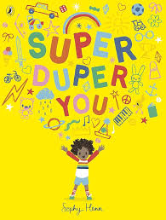
Week 3 | My Family | Sorting and counting songs | Vocabulary to describe a family | 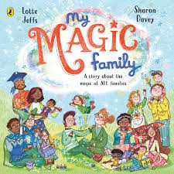
Week 4 | My Friends / feelings | My day – days of week and introduce calendar | Vocabulary to describe their feelings  Find their name | 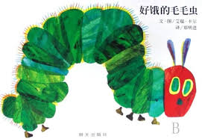
Week 5 | Where I Live | Patterns and 2D shape | Vocabulary to describe a home | 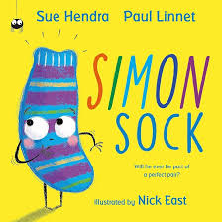
Week 6 | Special Landmarks | Measurement, Size and Length | Positional language | 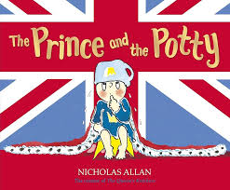
Week 7 | Festivals I celebrate | Principles of Counting | Vocabulary to describe celebrations | 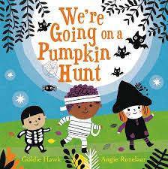
Week 8 | Festivals around the World | Comparing Amounts | Reading funamentals recapped and different language | 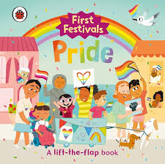

Term 2 | Topic title | Maths | English
Week 1 | Celebration - Fireworks | Number 1  Symmetry | Colours recap  I spy….. | 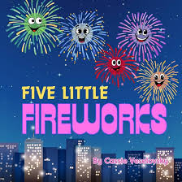
Week 2 | The Farm | 2 D Shapes  Number 2  Counting skills | Vocabulary to describe farm animals (visit)  Trace over names | 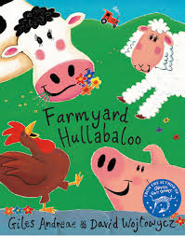
Week 3 | The Farm | Number 3  How many …..?  How many…….? | Vocabulary to describe farm animals (visit) | 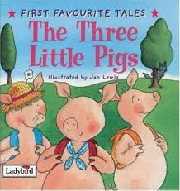
Week 4 | Wildlife | Recap numbers 1-3 | Vocabulary to describe other wild animals  Rhymnes | 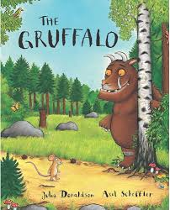
Week 5 | Safari | Number 4 | Vocabulary to describe safari animals  Rhymne | 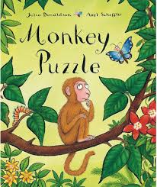
Week 6 | Celebration – Christmas | Number 5  Positional language | Christmas  vocabulary  Lists and letters | 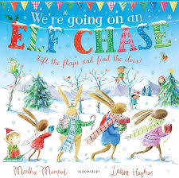
Week 7 | Celebration – Christmas | Number 6 | Recap the Nativity story | 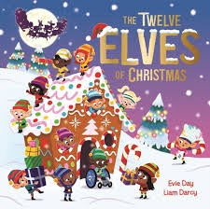

Term 3 | Topic title | Maths | English
Week 1 | Superhero’s? | Days of the week & times of day  Recap numbers 1-6 | Vocabulary of occupations  Trace name | 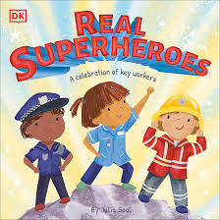
Week 2 | People who help us - Hospitals | Number 7  Colours | Vocabulary to describe hospitals  Phonics start | 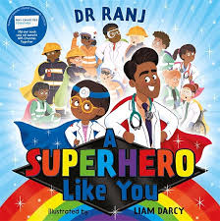
Week 3 | People who help us – Rescue Services | Number 8  Measurement weight | Vocabulary to describe rescue services | 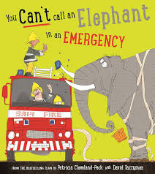
Week 4 | People who save us by the sea | Number 9  Capacity – greater, smaller | Vocabulary to describe dangers at sea | 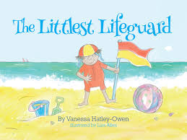
Week 5 | People who work through the Night | Number 10  More than, less than |  | 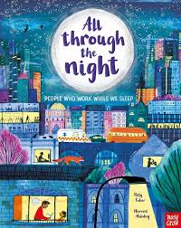

Term 4 | Topic title | Maths | English
Week 1 | What can I be? – bus driver? | Measurement, weights and Capacity | Vocabulary to describe types of transport | 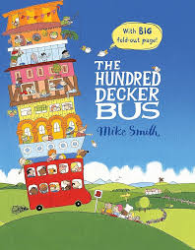
Week 2 | What can I be? – astronaut | Symmetry & patterns | Vocabulary to describe the sky & space | 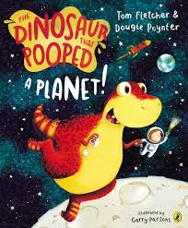
Week 3 | What can I be? Zoo keeper | Sorting and positioning | Listening to longer stories  Rhymne | 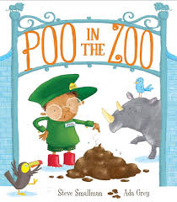
Week 4 | Looking after ourselves | Days of the Week | Vocabulary to describe safety and feelings | 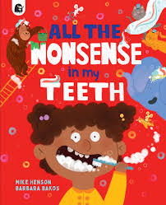
Week 5 | Can I look after a Dinosaurs | Patterns, 2D and 3D shape  Time | Past and present vocabulary | 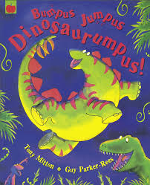
Week 6 | What’s in an egg?  Easter | Measurement, Size and Length | Vocabulary of size, shape and time  Positional language | 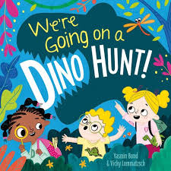

Term 5 | Topic title | Maths | English
Week 1 | Traditional tales – Jack and the Beanstalk  Growing and planting | Recap Numbers 7-10  Counting to 10 | Vocabulary to describe used in book | 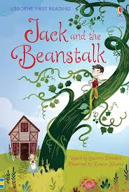
Week 2 | Traditional tales – Goldilocks and the Three Bears  Food types | Large and small amounts  My day | Vocabulary to describe used in book including size  List of food | 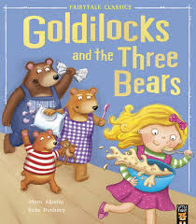
Week 3 | Traditional tales – The Ugly Duckling  Life cycles –babies | Counting to 10 and beyond  Height and Weight – balancing | Vocabulary to describe used in book including feelngs | 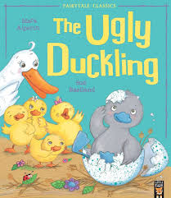
Week 4 | Traditional tales – Hansel and Gretel  Cooking | Colours and patterns | Vocabulary to describe used in book  List of sweets | 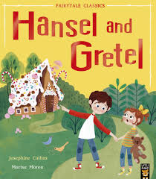
Week 5 | Traditional tales – Little Red Riding Hood  Cooking & baking | Recap on numbers 1-5 | Vocabulary to describe used in book | 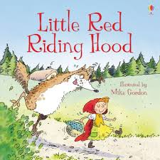
Week 6 | Nursery Rhymes  Mini-beasts, Insects, and spiders | Recap on numbers 6-10 | Vocabulary linked to song and rhyme | 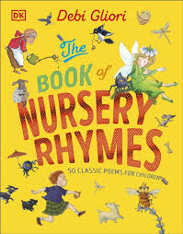

Term 6 | Topic title | Maths | English
Week 1 | Adventures in the Garden | Recap on numbers 1-10 | Vocabulary to describe oceans and pirates | 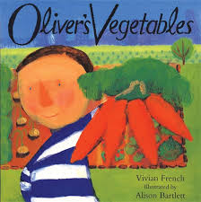
Week 2 | Adventures in the Garden | Counting to 10 and beyond | Vocabulary to describe the beach | 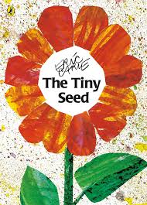
Week 3 | Adventures in the Garden | More. Less, amounts and positions | Vocabulary to describe life on the beach | 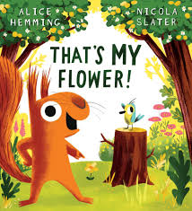
Week 4 | Life on the ocean – Pirate | Days of the week | Vocabulary to describe oceans and pirates | 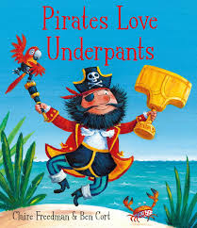
Week 5 | The Beach | Shapes 2D and 3D | Vocabulary to describe the beach | 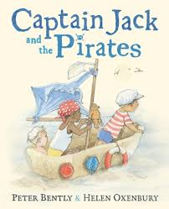
Week 6 | The Seashore | More and less and capacity | Vocabulary to describe life on the beach | 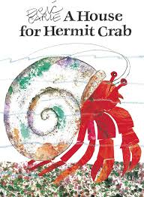
Week 7 | Getting School Ready | Height and Weight – balancing | Vocabulary to describe our feelings | 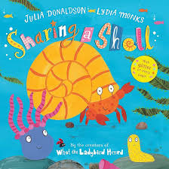
Week 8 | Getting School Ready | Recap ready for school | Vocabulary to describe our feelings | 