eSchool Braywood VLE – parent portal
http://www.braywoodschool.co.uk/web
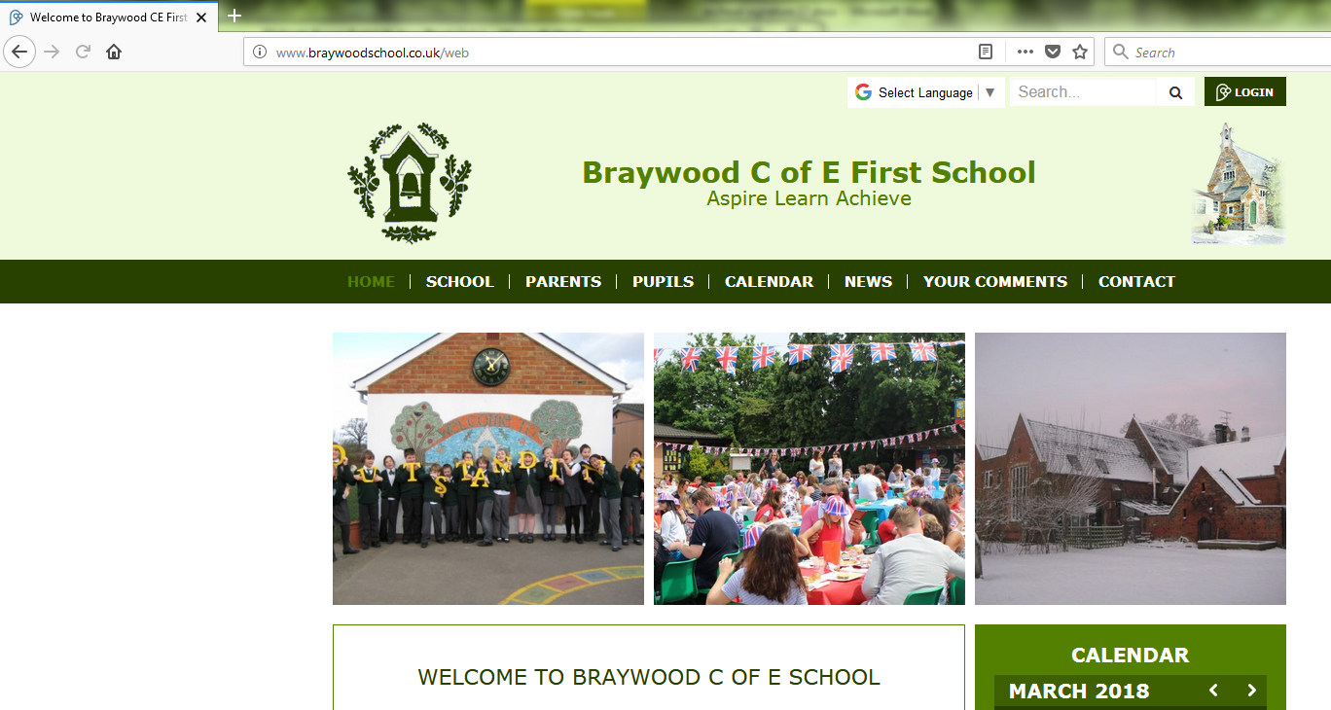
To log onto the parent portal click on this button
Log in will need both your name firstname.surname and your 4 digit numerical password (issued by staff).
This will allow you access to this page.
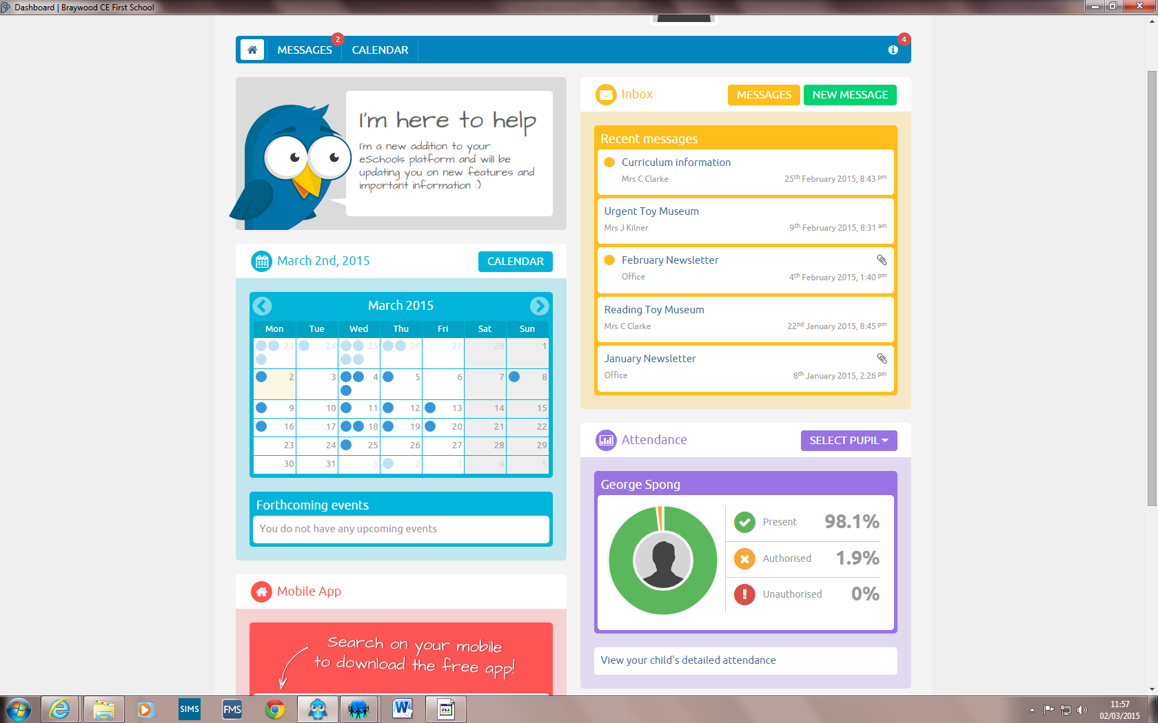
Clicking on each section allows you to access more detail.

Clicking on the Calendar will give you this
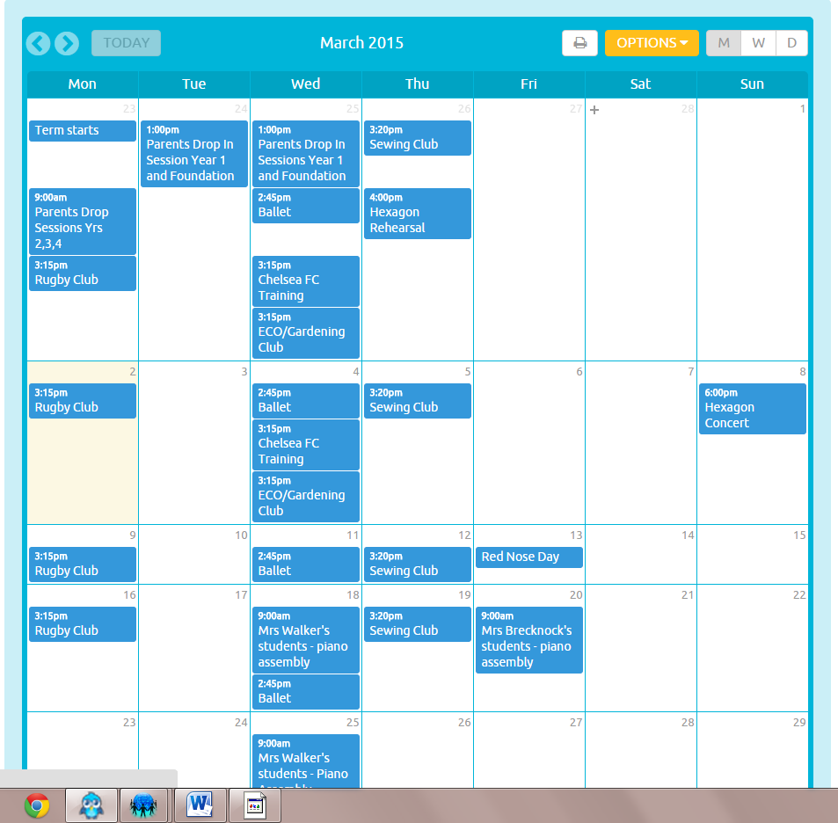

Double clicking on the event leads you to
more specific information like start and finish times

This shows there are 2 unread new messages which can be read by double clicking
on the Message section , opening this page -
Double click any of these to access the letters themselves. These can be replied to internally within the Eschool website.

If you want to write a message to a teacher click on New Message for a blank template.
NB. if your message is urgent it will be quicker to call or email the office or talk to the teacher at pickup/drop off.

You can see attendance information for all your children at Braywood – click on select pupil and chose from drop down
Carol
Adam

