Braywood CE First School
Curriculum map for Foundation 2 (Reception) Introductory Work Term 1
INTENT - Marvellous Me!
All about me, me and my family, farms and farm animals, Harvest, Autumn, Diwali, Bonfire night, Remembrance, disabilities, St Andrews Day, Christmas and Nativity, Money.
Be Safe  School Experience  Exploring our new surroundings  Using equipment safely  Cookery  Skills and Preparation  Bread  Fruit kebab | Enjoy and Achieve  Literacy  Read Write Inc.  All about Me  Maths  Counting, patterns and Seasons  Topic Assignment  Marvellous Me!  Expressive Art and Design and Music  Construction  Junk modelling  Playdough  Computing  Internet safety  How to use equipment safely | Be Healthy  Physical Education  How to use equipment safely  Co-ordination  Fine and Gross motor skills  Understanding the World  Farm Animals  Communication and Language  Marvellous Me Bag  (Show and tell)
Achieve Economic Well-being  Citizenship  Classroom rules and routines  Meeting Year 4 buddies  Harvest Festival  Mums and Dads into School  Autumn  Saving money to give to Harvest |  | Make a Positive Contribution  PSHE  New Beginnings (SEAL)  Making friends  Being kind and playing nicely  Religious Education  Diwali  What Makes people special ?  (DRE – Christianity & Judaism)  Music  Music unit - Exploring sounds and instruments

CONTINUOUS PROVISION TO INCLUDE SAND AND WATER ETC
Marvellous Me! |  |  | Foundation Stage 2
 | Literacy, Communication and Language | Mathematics | Understanding the World
 | - Recognising and continuing rhyming strings  - Listening to and showing interest in books & illustrations, handling books correctly and with care  - Recognising familiar words & extending vocabulary  - Hearing and saying initial sounds in words  - Writes name  - Listening and following instructions  - Understanding the use of different objects  - Promoting language in role play situations | - Develop fast recognition of up to 3 objects, without having to count them individually (‘subitising’). Recite numbers past 5. Say one number for each item in order: 1,2,3,4,5. Know that the last number reached when counting a small set of objects tells you how many there are in total (‘cardinal principle’).  Show ‘finger numbers’ up to 5. Link numerals and amounts: for example, showing the right number of objects to match the numeral, up to 5. Experiment with their own symbols and marks as well as numerals.  - Talk about and identifies the patterns around them. For example: stripes on clothes, designs on rugs and wallpaper. Use informal language like ‘pointy’, ‘spotty’, ‘blobs’, etc. Extend and create ABAB patterns – stick, leaf, stick, leaf. Notice and correct an error in a repeating pattern.  - Count objects, actions and sounds. Subitise. Link the number symbol (numeral) with its cardinal number value. Continue, copy and create repeating patterns. | - Talk about members of their immediate family and community, . to the rest of the class. Names and describe people who are familiar to them.  - Comments on images of familiar situations in the past.

IMPLIMENTATION - Subject Objective | IMPACT - Assessment
Personal, Social & Emotional Development | Beginning | Secure | Mastery
- Using the environment confidently, asking for help when needed  - Welcoming responsibility and praise  - Gaining an awareness of expected behaviour  - Interacting with others confidently and co-operatively, acknowledging & responding to their needs and feeling | Needs encouragement to access resources. Shows an understanding of class rules. | Independently gathers resources from appropriate area. Understands & follows class rules, some of the time. | Independently gathers correct resources from around the classroom. Understands & follows class rules, most of the time.
Physical Development
- Negotiating space and controlling gross-motor movements.  - Using tools and construction materials safely with increasing control.  - Holding writing tools using tripod grip.  - Managing basic hygiene and safety needs | Able to hold a pencil comfortably and make letter like shapes. Uses a dominate hand. | Uses modified tripod grip.  Is able to form basic recognisable letters. | Uses correct pencil grip and forms letters well.
Expressive Arts & Design
- Safely use and explore a variety of materials, tools and techniques, experimenting with colour, design, texture, form and function.  - Share their creations, explaining the process they have used. | Seeks help to select appropriate tools, objects, building and  malleable materials. | Uses various building materials Selects and uses various tools, objects, building and malleable materials. | Handles tools, objects, building and malleable materials safely and with increasing control
- ICT
- Operating simple technology such as toys  - To understand that information can be retrieved from computers | Turns on a computer with support. Needs adult help to complete a simple program. | Turns on a computer. Able to complete a simple program with encouragement. | Turns on a computer and completes a simple program independently.
Religious education and world views
- To develop a growing sense of the child’s awareness of self, their own  community and their place within this. | Talk about people who are special to them. Say what makes their family and friends special to them | Identify some of the qualities of a good friend. Recall and talk about stories of Jesus as a friend to others. | Recall a story about a special person and talk about what can be learnt from it

Braywood CE First School
Curriculum map for Foundation 2 (Reception) Term 2
INTENT - Fun on the Farm
Autumn, Diwali, Bonfire night, Remembrance, disabilities, St Andrew’s Day, Christmas and Nativity, Money.
Be Safe  School Experience  Exploring our new surroundings  Using equipment safely  Cookery  Skills and Preparation  Baking Bread  Goats cheese pizza  Gingerbread Man | Enjoy and Achieve  Literacy  Read Write Inc.  Big Write – Trouble on the Farm  The 3 Billy Goats Gruff  Maths  Counting, measurements and money  Topic Assignment  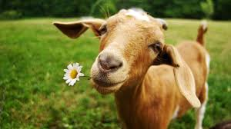  Fun on the Farm  Expressive Art, Design and Music  Construction  Junk modelling  Playdough  Music unit - Exploring sounds and instruments  Computing  Interact white Boards  How to use equipment safely, inc. Computers | Be Healthy  Physical Education  Co-ordination  Fine and Gross motor skills  Spatial Awareness  Using hoops  Understanding the World  Farm Animals  Diwali  Communication and Language  The Adventures of Flat Stanley  (Show and tell)
Achieve Economic Well-being  Citizenship  Diwali  Bonfire night  Remembrance Day  St Andrew’s Day  Christmas Fair  Saving money for the needy at Christmas and attend the Nativity concert |  | Make a Positive Contribution  PSHE  Getting on and falling out (SEAL)  Making friends  Being kind and playing nicely  Religious Education  Birthday of Guru Nanak  Hanukah  Diwali  What is Christmas? (DRE - Christianity)  Why do Christians perform Nativity plays at Christmas? (Incarnation - UC)

CONTINUOUS PROVISION TO INCLUDE SAND AND WATER
Fun on the Farm |  |  | Foundation Stage 2
 | Literacy, Communication and Language | Mathematics | Understanding the World
 | - Joining in with rhymes and stories  - Understanding that print carries meaning and that information can be found in books / ICT  - Giving meaning to mark making  - Linking sounds to letters, naming and sounding the letters of the alphabet  - Listening to and joining in with rhymes and stories  - Maintaining attention for appropriate time span  - Understanding humour, why/how questions and two-part instructions  - Using complex language with increasing accuracy | - Solve real world mathematical problems with numbers up to 5. Talk about and explore 2D and 3D shapes (for example, circles, rectangles, triangles and cuboids) using informal and mathematical language: ‘sides’, ‘corners’; ‘straight’, ‘flat’, ‘round’. Understand position through words alone – for example, “The bag is under the table,” – with no pointing. Make comparisons between objects relating to size, length, weight and capacity. Begin to describe a sequence of events, real or fictional, using words such as ‘first’, ‘then...’  - Count beyond ten. Compare numbers. Understand the ‘one more than/one less than’ relationship between consecutive numbers. Explore the composition of numbers to 10. Compare length, weight and capacity. | - Use all their senses in hands-on exploration of natural materials. Explore collections of materials with similar and/or different properties.  - Understand the key features of the life cycle of a plant and an animal. Begin to understand the need to respect and care for the natural environment and all living things.  - Explore and talk about different forces they can feel.  Talk about the differences between materials and changes they notice.  - Continue developing positive attitudes about the differences between people.

IMPLIMENTATION - Subject Objective | IMPACT - Assessment
Personal, Social & Emotional Development | Beginning | Secure | Mastery
- Being more outgoing towards unfamiliar people and situations  - Working together as a group  - Extending play by responding to other people’s ideas | Responds positively to a variety of familiar adults.  Shows affection towards other children & younger siblings. | Is more outgoing towards strangers & more confident in new social situations, although may be anxious at first. Forms a special friendship with another child | Confident in new social situations, including those with unfamiliar adults.
Physical Development
- Moving freely, confidently, experimenting with different ways of moving.  - Making large and small movements with good balance, control and co-ordination. Forming recognisable letters  - Dressing independently including fastenings | Takes off loose shirt when undone. Unzips coat. Can undo Velcro fasteners. | Pulls up trousers & zips already matched up.  Can undo some buttons. Puts arms into open coat when held up | Hangs up own coat  Buttons up clothes. Dresses independently.
Expressive Arts & design
- Make use of props and materials when role playing characters in narratives and stories.  - Invent, adapt and recount narratives and stories with peers and their teacher.  - Sing a range of well-known nursery rhymes and songs.  - Perform songs, rhymes, poems and stories with others, and (when appropriate) try to move in time with music. | Join junk modelling items  together and talk about what  they have made with them. | Enjoy exploring a wide range of ‘junk modelling’ and natural materials, making simple forms - building with 3D shapes | Handles tools, objects, building and malleable materials safely and with increasing control. Uses some technical ways of joining materials,  E.g. split pins, glues, and flaps.
ICT
- Operating simple technology such as toys  - Understanding that information can be retrieved from computers | Needs guidance to correctly close  websites or apps and safely turn device on and off. | Manage a device by correctly closing websites or apps and safely turning on and off. | Manage a device by logging in, logging out, shutting down where appropriate. And Knows the main parts of a computer.
Religious education and world views
- To recognise that Christians believe God came to Earth in human form as Jesus to show that all people are precious and special to God | Talk about people who are special to them. Say what makes their family and friends special to them | Recall simply what happens at a traditional Christian festival (Christmas) | Begin to recognise the word ‘incarnation’ as describing the belief that God came to Earth as Jesus. Retell religious stories, making connections with personal experiences.

Braywood CE First School
Curriculum map for Foundation 2 (Reception) Term 3
IMPACT - What hat shall I wear?
New year, New beginnings, targets, Winter, Healthy eating, Shops, colours and the rainbow, healthy living, exercise, the body, Chinese New Year, Pancake day, Lent
Be Safe  School Experience  Using equipment safely  Healthy Living  Cookery  Skills and Preparation  Frozen Banana Hats | Enjoy and Achieve  Literacy  Read Write Inc.  Big Write – Hetty’s Hat Shop  Maths  Numbers, symmetry, time, shapes  and measurements  Topic Assignment  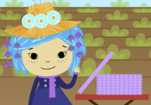  What hat shall I wear?  Expressive Art and Design and Music  Construction  Designing a hat  Playdough  Music unit - Exploring sounds and instruments  Computing  Interact white Boards  How to use equipment safely, inc. Computers | Be Healthy  Physical Education  Co-ordination  Fine and Gross motor skills  Ball skills  Understanding the World  Colour/Light Refraction  Occupations  Communication and Language  What Hat will I wear when I grow up?  (Brain Builder- Poster)
Achieve Economic Well-being  Citizenship  Chinese New Year  Pancake Day  Lent  Winter |  | Make a Positive Contribution  PSHE  Going for Goals (SEAL)  Making friends  Being kind and playing nicely  Religious Education  Epiphany  What makes places so special? (DRE – Christianity, Islam & Judaism)

CONTINUOUS PROVISION TO INCLUDE SAND AND WATER

What hat shall I wear? |  |  | Foundation Stage 2
 | Literacy, Communication and Language | Mathematics | Understanding the World
 | - Developing an awareness of the way stories are structured  - Listening to a range of stories with increasing attention recall  - Understanding that in English print is read from left to right and top to bottom  - Responding to stories with relevant comments & anticipating key events and listening attentively & responding to ideas  - Introducing storyline narrative into role-play games  - Understanding prepositions  - Enhancing language through the use of tenses, intonation, rhythm and phrasing | - Develop fast recognition of up to 3 objects, without having to count them individually (‘subitising’). Recite numbers past 5. Say one number for each item in order: 1,2,3,4,5. Know that the last number reached when counting a small set of objects tells you how many there are in total (‘cardinal principle’).  Show ‘finger numbers’ up to 5. Link numerals and amounts: for example, showing the right number of objects to match the numeral, up to 5. Experiment with their own symbols and marks as well as numerals.  - Talk about and identifies the patterns around them. For example: stripes on clothes, designs on rugs and wallpaper. Use informal language like ‘pointy’, ‘spotty’, ‘blobs’, etc. Extend and create ABAB patterns – stick, leaf, stick, leaf. Notice and correct an error in a repeating pattern.  - Count objects, actions and sounds. Subitise. Link the number symbol (numeral) with its cardinal number value. Continue, copy and create repeating patterns. | - Begin to make sense of their own life-story and family’s history.  - Show interest in different occupations.  - Explore how things work.  - Plant seeds and care for growing plants.

IMPLIMENTATION - Subject Objective | IMPACT - Assessment
Personal, Social & Emotional Development | Beginning | Secure | Mastery
- Learning to confidently voice needs, interests and opinions  - Learning to try new activities and deal with changes in routine  - Thinking positively about ourselves and our abilities  - Talking about how they & others show feelings, taking account of other’s feelings and taking steps to resolve conflict. | Shows concern towards others who are upset i.e. offers pats arm or back, offers cuddle etc. | Shows resilience and perseverance in the face of challenge. Can identify and moderate their own feelings socially and emotionally. | Understands that own actions affect other people i.e. becomes upset or tries to comfort another child when they realise they have upset them
Physical Development
- Showing increasing control when playing with small PE equipment.  - Forming recognisable letters using the correct formation.  - Gaining understanding of good health and safety practices | Throws ball underhand. Can catch a ball by chasing- does not necessarily respond to aerial ball. Bounces a large ball. Uses foot to tap static ball a small  Distance. Walks towards and kick a ball | Catches a large ball between extended arms. Catches a large ball by bringing hands  in towards chest. Bounces and catch a large ball using 2  hands. Walks towards and kick a ball towards a target | Throws a ball with intended direction. Hits 2ft target from 5ft away with a tennis ball using underhand toss. Catches a tennis ball from 5 feet using both hands - Bounces a tennis ball on the floor .  Can runs towards and kick a ball that is rolled to them.
Expressive Arts & design
- Safely use and explore a variety of materials, tools and techniques, experimenting with colour, design, texture, form and function.  - Share their creations, explaining the process they have used.  - Sing a range of well-known nursery rhymes and songs. | Perform poems, songs and rhymes as  part of my class/group, Learning new songs and actions to  support teacher-led narration. | Listen attentively, move to and talk about music, expressing my feelings and responses. | Begin to move in time with music. Start to express their feelings and  responses.to dance and  performance art. Recognise some tuned instruments.
ICT
- Complete a simple program on a computer using age-appropriate software.  - Children recognise that technology is in the home and school and can select and use technology for particular purposes. | Requires support to input commands using a mouse. Is able to use finger control to interact with a tablet (double tap, swipe) | Input commands using a mouse to control a cursor and use the left click to select options OR use finger control to interact with a tablet (double tap, swipe) | Input commands with increasing fluency using a mouse to control a cursor and use the left click to select options OR use finger control to interact with a tablet (double tap, swipe)
Religious education and world views
- To begin to make links to special places in their own lives and discuss and ask questions about why those places are special to each other. | Talk about somewhere that is special to themselves, saying why. Get to know and use appropriate words to talk about their thoughts and feelings when visiting a church | Recognize that some religious people have places which have special meaning for them. Talk about the things that are special  and valued in a place of worship. | Begin to recognise that for Christians, Muslims or Jews, these special things link to beliefs about God

Braywood CE First School
Curriculum map for Foundation 2 (Reception) Term 4
INTENT – What Hat shall I wear?
St. David’s Day, internet safety, Mother’s Day, St. Patrick’s Day, eggs, dinosaurs, Easter.
Be Safe  School Experience  Using equipment safely  Cookery  Skills and Preparation  Easter Tomb Biscuits | Enjoy and Achieve  Literacy  Read Write Inc.  Big Write – The Mystery Egg  World Book Day  Maths  Numbers, money and time  Topic Assignment  The Mysterious Egg?  (Ducklings)  Expressive Art and Design and Music  Construction  Singing  Playdough  Music unit - Exploring sounds and instruments  Computing  IWB  Beebots | Be Healthy  Physical Education  Co-ordination  Trim Trail  Climbing  Understanding the World  Healthy Living – Our Body  Past and Present  Ducklings and other animals that hatch from eggs (CL)  Communication and Language  My Favourite Book  (Show and tell)
Achieve Economic Well-being  Citizenship  St. David’s Day  Mothering Sunday  Easter Music Concert and collection  Spring  Ducklings |  | Make a Positive Contribution  PSHE  Feels good to be me (SEAL)  Making friends  Being kind and playing nicely  Religious Education  Why do Christians put a cross in an Easter Garden ? (UC – Salvation)  What is Easter (DRE - Christianity)

CONTINUOUS PROVISION TO INCLUDE SAND AND WATER
The Mysterious Egg |  |  | Foundation Stage 2
 | Literacy, Communication and Language | Mathematics | Understanding the World
 | - Describing main story settings, character’s, & events demonstrating an understanding of what has been said  - Breaking the flow of speech into words and writing sentences that match those spoken sounds.  - Segmenting sounds in simple words & blending them together, using identifiable letters to represent them  - Understanding and responding to complex instructions  - Answering who, what, when & how questions in response to events & stories and showing awareness of listeners needs  - Using past, present & future forms correctly  - Using language to connect ideas or events | - Develop fast recognition of up to 3 objects, without having to count them individually (‘subitising’). Recite numbers past 5. Say one number for each item in order: 1,2,3,4,5. Know that the last number reached when counting a small set of objects tells you how many there are in total (‘cardinal principle’).  Show ‘finger numbers’ up to 5. Link numerals and amounts: for example, showing the right number of objects to match the numeral, up to 5. Experiment with their own symbols and marks as well as numerals. 28. Automatically recall number bonds for numbers 0-5 and some to 10.  - Talk about and identifies the patterns around them. For example: stripes on clothes, designs on rugs and wallpaper. Use informal language like ‘pointy’, ‘spotty’, ‘blobs’, etc. Extend and create ABAB patterns – stick, leaf, stick, leaf. Notice and correct an error in a repeating pattern.  - Count objects, actions and sounds. Subitise. Link the number symbol (numeral) with its cardinal number value. Continue, copy and create repeating patterns. | - Begin to make sense of their own life-story and family’s history.  - Show interest in different occupations.  - Explore how things work.  - Plant seeds and care for growing plants.

IMPLIMENTATION - Subject Objective | IMPACT - Assessment
Personal, Social & Emotional Development | Beginning | Secure | Mastery
- Show an understanding of their own feelings and those of others, and begin to regulate their behaviour accordingly.  - Set and work towards simple goals, being able to wait for what they want and control their immediate impulses when appropriate.  - Give focused attention to what the teacher says, responding appropriately even when engaged in activity, and show an ability to follow instructions involving several ideas or actions | Beginning to adjusts their behaviour according to the needs of others.. Starting to follow multi-level instructions accurately some of the time even. Is often able to play cooperatively and wait their turn. | Can adjusts their behaviour according to the needs of others.. Able to follow multi-level instructions accurately some of the time even. Is able to play cooperatively and wait their turn, some of the time. | Able to adjusts behaviour according to the needs of others, some of the time. Able to follow multi-level instructions accurately most of the time even when focused. Able to play cooperatively and wait their turn all of the time.
Physical Development
- Using climbing, balancing and jumping apparatus safely and confidently  - Observing the effects of physical activity | Climbs and uses climbing equipment when an adult is nearby. Climbs up apparatus, using two feet - Climbs above their own head height | Climbs upstairs using alternative feet - Climbs up apparatus using two feet. Can jump forward about 60 cm (2 feet). | Confidently uses climbing equipment without needing encouragement. Performs different movements on a  climbing frame, such as swinging.
Expressive Arts & design
- Safely use and explore a variety of materials, tools and techniques, experimenting with colour, design, texture, form and function.  - Sing a range of well-known nursery rhymes and songs. | Requires support to access resources. Struggles with scissor control. Snips paper moving forward - Uses helping hand to hold and help to guide the paper (non-dominant hand) - Cuts curved line with some accuracy. | Needs encouragement to access the appropriate resources. Cuts circle shape with increasing accuracy. Cuts square shape | Independently gathers appropriate resources from around the classroom. Excellent scissor control. - Cuts complex shapes, such as figures.
ICT
- Completes a simple program on a computer.  - Uses ICT hardware to interact with age-appropriate computer software.  - Children recognise that a range of technology is used in places such as homes and schools. They select and use technology. | Requires support to input commands using the space bar, backspace, enter, letters and numbers on a keyboard on any device (including on a tablet). | Input commands using the space bar, backspace, enter, letters and numbers on a keyboard on any device (including on a tablet). | Input commands with increasing fluency using the space bar, backspace, enter, caps lock, letters, numbers and common symbols/punctuation on a keyboard on any device (including on a tablet).
Religious education and world views
- To recognise that Christians remember Jesus’ last week at Easter.  - To recognise that Christians believe Jesus came to show God’s love  - To recognise that Christians try to show love to others | Talk about ideas of new life in nature. Recognise some symbols Christians  use during Holy Week, e.g. palm leaves, cross, eggs, etc., and make  connections with signs of new life in nature | Recognise and retell stories connected with celebration of Easter. Say why Easter is a special time for  Christians | Talk about some ways Christians  remember these stories at Easter

Braywood CE First School
Curriculum map for Foundation 2 (Reception) Term 5
INTENT - Exploring our World
Changes, St. Georges Day, dragons, plants and life-cycle, mini-beasts, maps and directions, textures
Be Safe  School Experience  Using equipment safely  Cookery  Skills and Preparation  Butterfly Cupcakes | Enjoy and Achieve  Literacy  Read Write Inc.  Big Write – Lost in the Garden  Maths  Number sentences, shapes and time  Topic Assignment  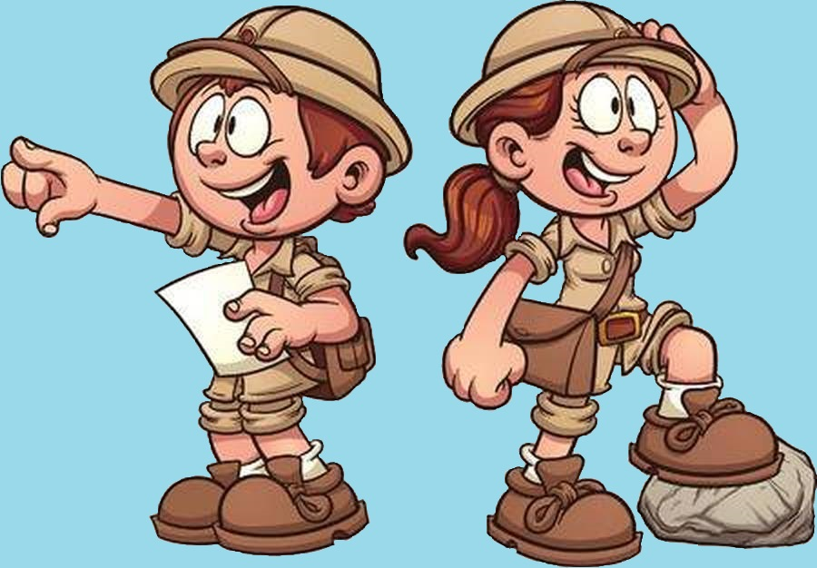  Exploring our World  Lost in The Garden – An Adventure  Expressive Art and Design and Music  Music unit - Exploring sounds and instruments  Computing  IWB  Computers  Beebots | Be Healthy  Physical Education  Co-ordination  Balance  Understanding the World  Plants  Mini- beasts  Communication and Language  What’s inside my Garden  (Brain Builder)
Achieve Economic Well-being  Citizenship  St. George’s Day  Summer Fair  Summer |  | Make a Positive Contribution  PSHE  Relationships (SEAL)  Changes (SEAL)  Religious Education  What can we learn from Stories? (DRE – Buddhism, Christianity, Islam, Hinduism & Sikhism)

CONTINUOUS PROVISION TO INCLUDE SAND AND WATER
Exploring our World - Lost in The Garden – An Adventure |  |  | Foundation Stage 2
 | Literacy, Communication and Language | Mathematics | Understanding the World
 | - Suggesting how a story might end  - Using vocabulary that is influenced by books  - Using phonic knowledge to read and write simple sentences that include some common irregular words  - Producing writing that can be read by others | - Have a deep understanding of number to 10, including the composition of each number. Subitise (recognise quantities without counting) up to 5. Automatically recall (without reference to rhymes, counting or other aids) number bonds up to 5 (including subtraction facts) and some number bonds to 10, including double facts.  - Verbally count beyond 20, recognising the pattern of the counting system. Compare quantities up to 10 in different contexts, recognising when one quantity is greater than, less than or the same as the other quantity. Explore and represent patterns within numbers up to 10, including evens and odds, double facts and how quantities can be distributed equally. | - Compare and contrast characters from stories, including figures from the past.  - Explore the natural world around them.  - Describe what they see, hear and feel whilst outside.

IMPLIMENTATION - Subject Objective | IMPACT - Assessment
Personal, Social & Emotional Development | Beginning | Secure | Mastery
- Explain the reasons for rules, know right from wrong and try to behave accordingly.  - Manage their own basic hygiene and personal needs, including dressing, going to the toilet and understanding the importance of healthy food choices. | Remember rules without needing an adult to remind them, understanding why they are  important.  Beginning to understand the need for a healthy life style. | Able to explain the reasons for most rules. Starting to understand the  importance of a healthy life style. Recognise how exercise makes them feel | Able to explain the reasons for the rules. Deepening their understanding of the importance of a healthy life style. Recognise how exercise makes them feel.  Able to explain what they need to do to stay healthy and give examples of healthy food.
Physical Development
- Demonstrate strength, balance and coordination when playing.  - Move energetically, such as running, jumping, dancing, hopping, skipping and climbing. | Walks along a low, wide  balance beam independently. Holds a controlled static  balance on one leg | Walks along a low narrow  balance | Balances on an unstable  surface with increasing  control
Expressive Arts & design
- Safely use and explore a variety of materials, tools and techniques, experimenting with colour, design, texture, form and function.  - Share their creations, explaining the process they have used. | Draws potato people (no neck or body) Demonstrates more control - Draws with detail (bodies with sausage limbs and additional features) - Draws bodies of an appropriate size for what they’re drawing | Beginning to draw self-portraits, landscapes and buildings/cityscape. Draws objects and creatures in proportion to each  other (e.g. elephant is bigger than a dog) Spends a sustained amount of time on one product. | Refine their drawing skills so that they can represent objects with increasing skill observational drawings of minibeasts and shells.  Looks closely at lines, shapes, size and patterns
ICT
- Completes a simple program on a computer.  - Uses ICT hardware to interact with age-appropriate computer software.  - Children recognise that a range of technology is used in places such as homes and schools.  - They select and use technology for particular purposes. | Needs support to programme the Beebot | Independently programme the Beebot to complete an instruction. | Independently programme the Beebot to complete a sequence of instructions.
Religious education and world views
- To recognise that people may have special books.  - To recognise that many people learn about ways of living from books and  - stories. | Identify some of their own feelings in the stories they hear | Talk about some religious stories. Recognise some religious words, e.g. about God | Identify a sacred text e.g. Bible, Torah, Qur’an. Talk about some of the things these stories teach believers (for example, what Jesus’ story about the ten lepers teaches about saying ‘thank you’, and why it is good to thank and be thanked

Braywood CE First School
Curriculum map for Foundation 2 (Reception) Term 6
INTENT - Exploring our World
Technology, occupations, Father’s Day, Summer, Sea and beaches, capacity, float or sink, recycling, Eid, transitions.
Be Safe  School Experience  Using equipment safely  Cookery  Skills and Preparation  Salad Minibeast’s | Enjoy and Achieve  Literacy  Read Write Inc.  Big Write – Lost in the Garden  Maths  Number sentences, money and measurment  Topic Assignment  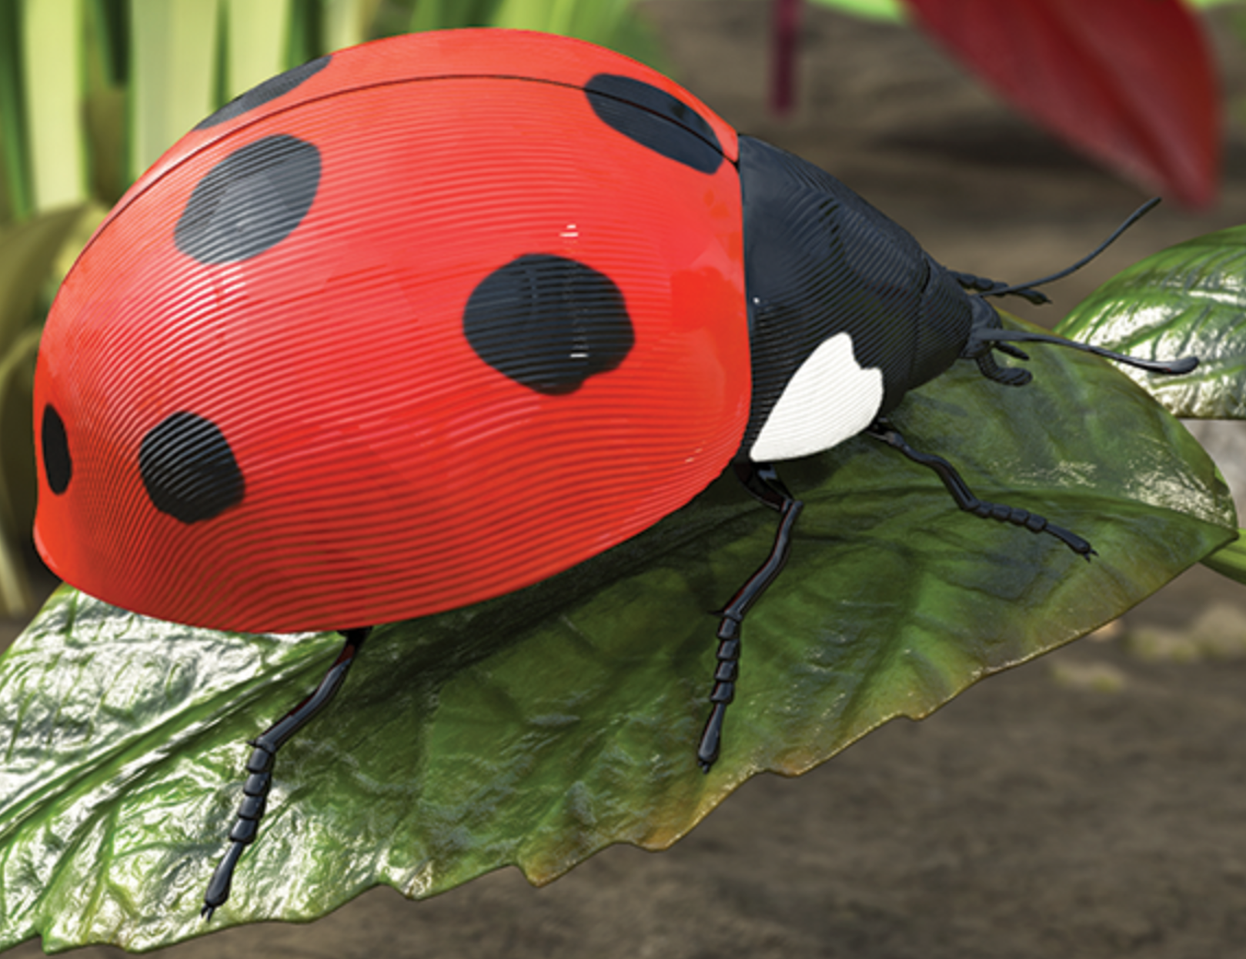  Exploring our World - Lost in The Garden – Bug Safari  Expressive Art and Design and Music  Music unit - Exploring sounds and instruments  Computing  IWB  Computers  Beebots | Be Healthy  Physical Education  Sport’s Day  Understanding the World  Plants  Mini- beasts  Recycling  Communication and Language  Mini Beast fact  (Brain Builder)  What I have enjoyed in FS 2 and am looking forward to in year one.
Achieve Economic Well-being  Citizenship  Father’s Day  Sport’s Day  Transition to Year 1 |  | Make a Positive Contribution  PSHE  Saying No to Bullying (SEAL)  Changes (SEAL)  Religious Education  Why is the word ‘God’ so important to Christians? (Creation - UC)  Eid

CONTINUOUS PROVISION TO INCLUDE SAND AND WATER
Exploring our World - Lost in The Garden – Bug Safari |  |  | Foundation Stage 2
 | Literacy, Communication and Language | Mathematics | Understanding the World
 | - Suggesting how a story might end  - Using vocabulary that is influenced by books  - Using phonic knowledge to read and write simple sentences that include some common irregular words  - Producing writing that can be read by others  - Using past, present & future forms correctly  - Answering who, what, when & how questions in response to events & stories and showing awareness of listeners needs  - Revisiting areas that need consolidating. | - Have a deep understanding of number to 10, including the composition of each number. Subitise (recognise quantities without counting) up to 5. Automatically recall (without reference to rhymes, counting or other aids) number bonds up to 5 (including subtraction facts) and some number bonds to 10, including double facts.  - Verbally count beyond 20, recognising the pattern of the counting system. Compare quantities up to 10 in different contexts, recognising when one quantity is greater than, less than or the same as the other quantity. Explore and represent patterns within numbers up to 10, including evens and odds, double facts and how quantities can be distributed equally.  - Revisiting areas that need consolidating. | - Draw information from a simple map.  - Understand that some places are special to members of their community.  - Recognise that people have different beliefs and celebrate special times in different ways.  - Recognise some similarities and differences between life in this country and life in other countries.  - Recognise some environments that are different to the one in which they live.  - Understand the effect of changing seasons on the natural world around them.  - Revisiting areas that need consolidating.  - NC Science if applicable

IMPLIMENTATION - Subject Objective | IMPACT - Assessment
Personal, Social & Emotional Development | Beginning | Secure | Mastery
- Be confident to try new activities and show independence, resilience and perseverance in the face of challenge. (Moving to Year 1) | Show resilience and perseverance in the face of challenge. | Confident to try new activities, most of the time, showing independence, resilience and perseverance in the face of challenge. | Confident to try new activities, showing independence, resilience and perseverance in the face of challenge.
Physical Development
- Negotiate space and obstacles safely, with consideration for themselves and others  - Move energetically, such as running, jumping, dancing, hopping, skipping and climbing. | Developing a fluid motion of movement  with control and  grace. | Can moves around obstacles with a fluid motion. | Can gage where a moving obstacle may be and move  themselves appropriately  before reaching it, even when travelling at speed
Expressive Arts & design
- Make use of props and materials when role playing characters in narratives and stories.  - Sing a range of well-known nursery rhymes and songs.  - Perform songs, rhymes, poems and stories with others, and (when appropriate) try to move in time with music. | Know a wide variety of well-known nursery rhymes and can learn some new songs as well. | Sing in a group or on my own with an  increasing ability to match the pitch  and follow the melody | Begin to make up verses to songs by  changing the words but keeping the rhythm e.g. ‘Going on a Bear Hunt
ICT
- Completes a simple program on a computer.  - Uses ICT hardware to interact with age-appropriate computer software.  - Children recognise that a range of technology is used in places such as homes and schools.  - They select and use technology for particular purposes. | Starting to recognise technology that is used at home and in school.. Understand what a computer is and the different uses of computers i.e. Learning, communicating, finding information, playing games etc. | Recognise technology that is used at home and in school.. Understand what a computer is and the different uses of computers i.e. Learning, communicating, finding information, playing games etc. | Recognise that devices can be connected. Understand the ways devices are used in the classroom and at home. Is able to search engine to find information
Religious education and world views
- To recognise that Christians believe God is the creator of the universe and that God made our wonderful world so we should look after it.  - To understand that The word God is a name. | Talk about the creation bible story and remember part of it. Think, talk and ask questions about living in an amazing world. | Know that Christians praise God for his amazing creation and design.  Recognise that ‘Creation’ is the beginning of the ‘big story’ of the Bible. | Understand what 'being a creator' means. (connections) and have a go at creating.

