Internet Safety
Our children love to use the internet specially to play games and to communicate with their friends. The way they start using computers and the guidance they are given at this young age can set them on the right path to being safer in later life.
At our school we ensure that our children are taught the basic tips of Internet Safety in every year group.
We recently had an Internet Safety Day. It was run by Paul Hay who is an expert in Internet Safety. Paul worked with the teachers to lead an assembly and run class lessons.
We use a cartoon which was created by the Child Exploitation and Online Protection agency (CEOPs).
You can see the cartoon on YouTube by clicking here.
https://www.youtube.com/watch?v=kEkNH8D6ub8
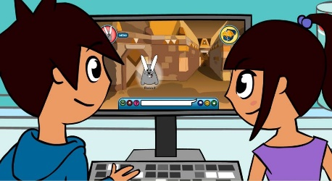
It tells the children the 4 Top Tips they need to remember.
- Top Tip 1 : People you don’t know are strangers. They’re not always who they say they are.
- Top Tip 2 : Be nice to people on the computer like you would in the playground.
- Top Tip 3 : Keep your personal information private.
- Top Tip 4 : If you ever get that ‘uh oh’ feeling, you should tell a grown-up you trust.
Click here to download and print your own “top Tips” poster http://www.pclstraining.com/app/download/2634043/Sids+Top+Tips+Poster.pdf
Parents
It is important for all parents to learn about how children use the internet so they can carry on the discussion with their own children at home.
Paul has provided links to useful sites to learn more about Internet Safety and watch other related videos. Here is the site
www.pclstraining.com/links
Paul is also happy for parents to contact him with any questions you may have.
paul.hay@pclstraining.com
"Digital Parenting" magazine
An organisation called Parentzone have created a great magazine for parents to help them understand how young people use the internet and provide help.
Click here to download your own copy
http://www.pclstraining.com/app/download/18417932/Digital+Parenting+Issue+7.pdf
If you need any help or guidance, please feel free to contact me paul.hay@pclstraining.com

