Braywood CE First School
Governors’ Report to Parents

2020-21

Aspire Learn Achieve, together

From little acorns, mighty oak trees grow, watered and nurtured by God

‘For with God, nothing is impossible’ Luke 1:37
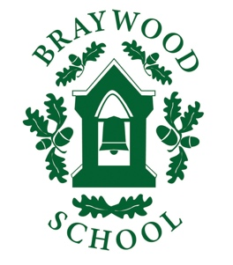
Message from the Chair of Governors

“At Braywood our aspirations are for all children to become confident, secure and caring individuals who achieve personal success through a love of learning”
Dear Parents and Carers

Firstly, my hope is that you and your families are safe and well after yet another unusual school year. I have just read my letter from last July and I didn’t expect us to be in the same situation as last year, albeit making progress to climb out of this dreadful pandemic.

I would like to thank, on behalf of the governors, the tremendous work that Mrs Calvert and all her staff have done throughout yet another difficult year. After Christmas we were faced with yet another lock down and remote learning, I think we all appreciate their excellent effort. I would also like to thank the office staff for keeping communication going throughout. You also did an extremely important job too, juggling again with work and home schooling couldn’t have been easy so thank you!

The governing body welcomes two new governors this year: Harri Uppal and Sarah Grace. We say farewell and a huge thank you to Barbara Frame, Alison Brayshaw and Sarah Moyniham who have served for many years at Braywood. We also welcome Izzy Sebire as the new year 1 teacher.

In the meantime, on behalf of myself and the governors, we again thank you for your support and understanding and please do continue to take care as we enjoy the summer holidays ahead.

Best wishes

Anne Farley
Chair of Governors
What have been our successes this year?

This year our main priority was keeping everyone safe and well through this all-consuming pandemic. This involved adhering to the Government guidelines, writing copious risk assessments, maintaining confidence levels in our procedures whilst supporting the wellbeing of the whole school community. During this year a strong infrastructure of virtual communication has been developed to provide remote learning and whole school collective worship. Some of the changes that have been made will be maintained.
All targets from last year were achieved including
- getting involved with the Y4 times table test trials – 82% of pupils achieved the expected standard.
- the new relationship education introduced by the Government is embedded and running smoothly
In June we were awarded the Inclusion Mark which highlights the inclusivity of our school.

Our standards this year

This is the second Governor’s Report to Parents that has been impacted by Covid 19. The biggest testament to the success of our school is how many pupils have maintained their academic success alongside supporting their happiness. It has been a challenge but approx. 90-94% of pupils across the school achieved expected levels. We may have slightly less pupils who have exceeded expectations due to the reduced time in school. Year 2 teacher assessment suggests that the optional KS1 SATs have also been very successful. All (100%) the pupils who took their phonics test in Year 2 achieved the standard and 96% of Y1 pupils achieved the optional Y1 phonic test.

The main reason why we have maintained our standards is that we started right from the beginning of the pandemic teaching the same curriculum as would have been expected to be taught on that day. Our whole school ‘catch-up’ programme run by all staff ensured that any child at risk of falling behind was also instrumental. We are very pleased with these results and they are a combined effort between the teachers and our parents.
What have we achieved this year?

PTA Events including fundraising for Captain Tom’s NHS charity
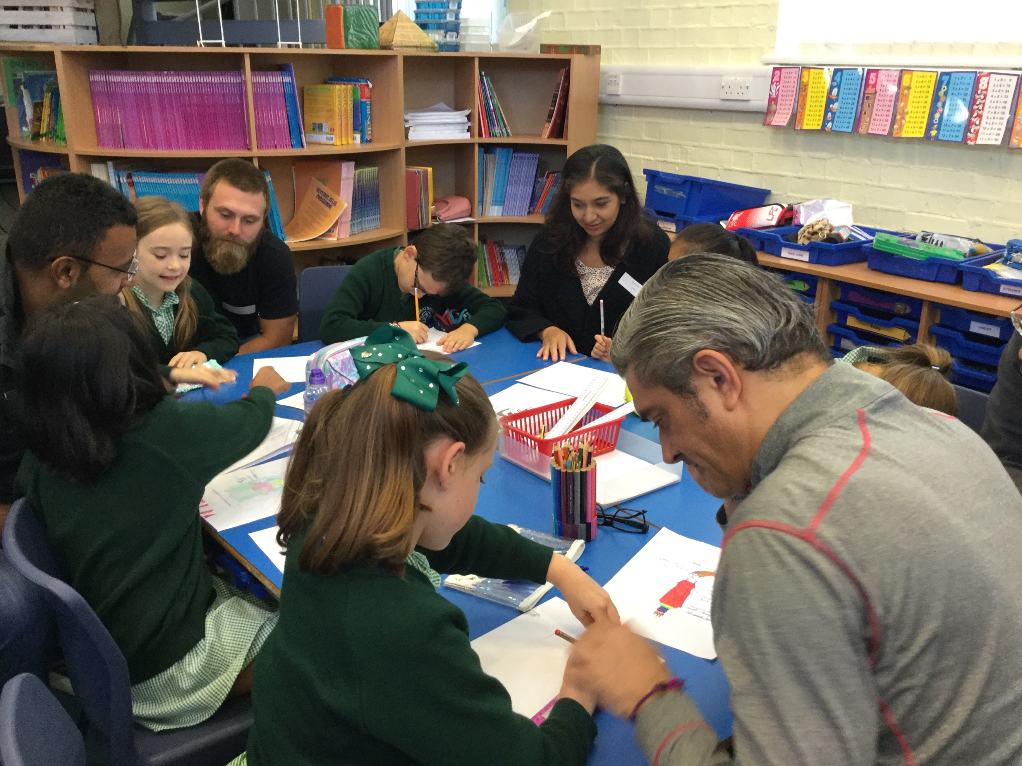
Virtual Pantomime and Nativity filmed
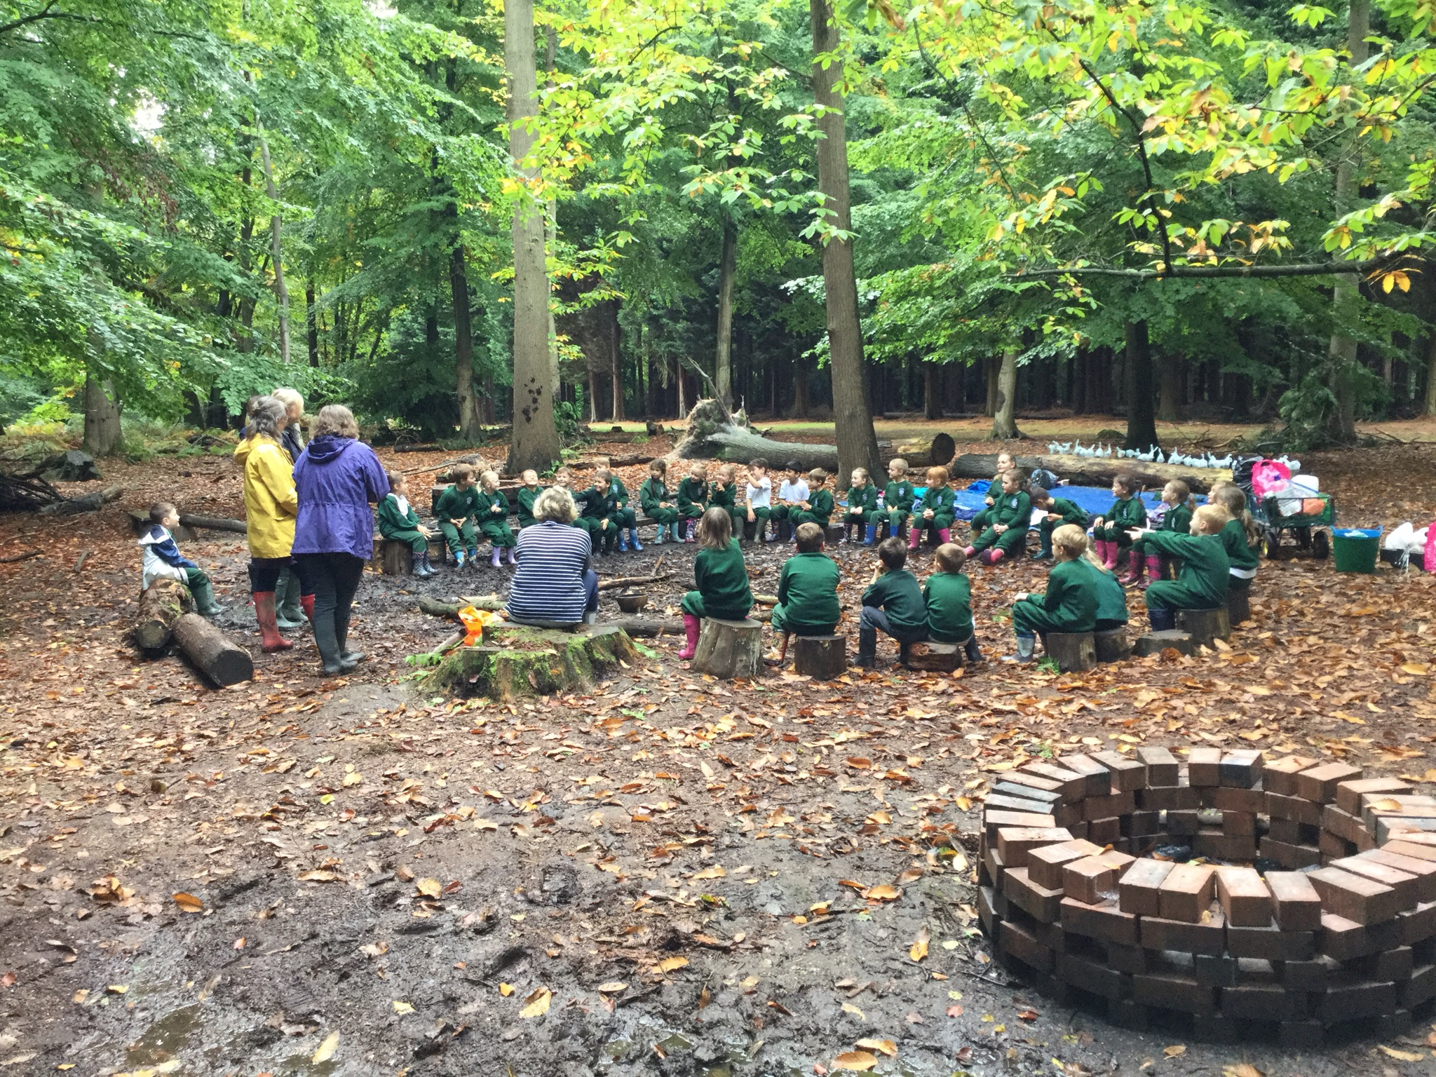
Harvest Festival filmed
Whole School Forest Trips in school
Y3 & 4 virtual trips to Ufton Court
Y2 virtual trip to Reading Museum
Hatching chickens in EYFS
Variety of charities supported incl Red Nose
Remote learning provided throughout lockdown
Virtual home learning opportunities for parents
Windsor Sports Partnership training & in-school tournaments
Virtual Collective Worship for everyone
Y1 virtual trip Windsor Castle
Y4 trip to Longridge
Induction visits for our new parents
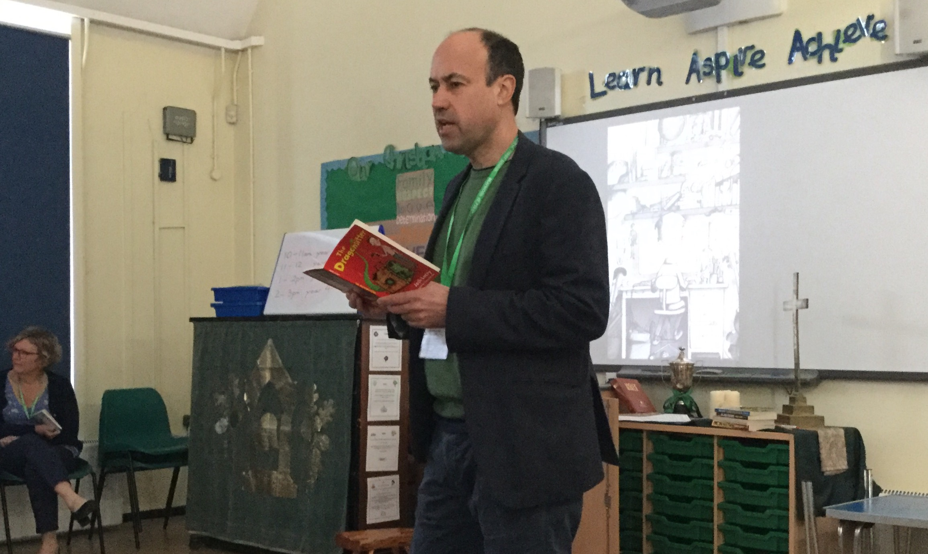
Variety our outdoor lessons using environment
Visitors into school to support topics
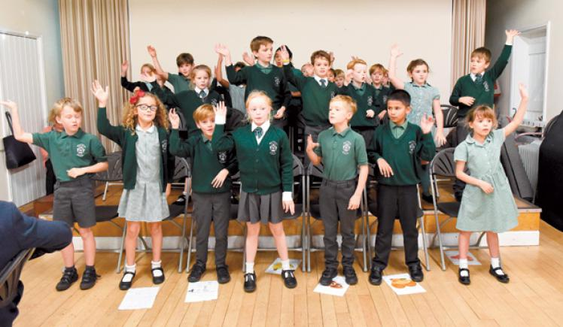
Literacy day
Maths Day
Parents talks during Entrepreneurial Day
Remembrance Service outside
Wellbeing coaching through WSSP
Summer Concert
Eco Club and climate change
Christmas events such as parties
Christingle Service together
Rock Steady and Piano lessons
Y4 leading Pupil Parliament, music, assemblies
Y4 running the school at the end of the year
Y1 planning a business & competitions
After school club include multi – skills club
Adapted a whole school ‘grab and go’
Virtual SEN / parents meetings
Easter Concert filmed
Regular emails from Headteacher
Eschools opened for parents
In-school Sports events
Y4 Summer Concert
Of all these activities have contributed to the breadth of our curriculum and nearly all of our usual activities have been achieved through this pandemic excepts trips outside of the school.

What are we trying to improve next year?

There are many priorities in our school development plan, but these are the key features.
- To get the school back to normal, regain the confidence and wellbeing of all through bringing life and colour into the school environment such as planting trees/bulbs, construct a ‘time-capsule with local community and celebrate 165 years of Braywood.
- Work alongside new partnership with St George’s School for new learning opportunities including the Queen’s Jubilee.
- Set up a parent’s committee who can add their thoughts to our school improvement plan.
Who are the Governors?
The Governors are a long serving group of people who are committed to the success of our school. There are a wide variety of skills on our Governing Body from a range of sources; some are local businesses, some parents, some representing our Christian bias, and some are educationists. We are the school’s ‘critical friend’.

For more informative see our page on the website http://www.braywoodschool.co.uk/web/our_governors__1/232576

How do our governors promote school improvement this year?
The Governors work in collaboration with the Headteacher and staff, creating a closely balanced partnership to ensure that the school is run effectively. Our aim is to ensure that we provide the very best education possible.

Our staff and governors are a strong team who meet or visit school regularly to refine our improvement plan; challenge staff and ensure that our learning environment is safe and non-discriminatory. Each governor together with an associated teacher leads in one or two subject areas. The Governing Body monitors school improvement priorities through meetings, lesson visits, work analysis, policies and procedures and the financial scrutiny.

How are we working with parents?
The school and our governors value the contribution of parents, whether it is the help you give your child with their learning, the support you give the school by attending events or helping your child attend trips or events and the support your offer out PTA.

.

The governors would like to wish everyone a lovely summer break and look forward to working with you all in the new academic year.

Chair of Governors
Mrs Anne Farley

