Braywood CE First School
Governors’ Report to Parents

2021-22

Aspire Learn Achieve, together

From little acorns, mighty oak trees grow, watered and nurtured by God

‘For with God, nothing is impossible’ Luke 1:37
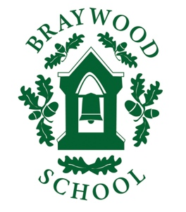
Message from the Chair of Governors

“At Braywood our aspirations are for all children to become confident, secure and caring individuals who achieve personal success through a love of learning”
Dear Parents and Carers

Firstly, my hope is that you and your families are safe and well after yet another unusual school year. Happily, it’s been a relatively Covid-free year, the Governors have been enjoying face-to-face meetings this year, let’s hope that it continues!

On behalf of the Governors, I would like to thank Susan Calvert, the teachers, support staff and office staff for their extremely hard work and dedication throughout this year at Braywood. School life still has its Covid ups and downs, but this has been expertly navigated by Susan’s leadership. The children have been very happy to return to the lovely trips, sports events and of course the wonderful musical events throughout the year.

We wish Nicola Povey all the best in her new teaching role and good wishes for the future.

On behalf of myself and all of the Governors, we wish you a restful, sunny summer.

Best wishes

Anne Farley
Chair of Governors

What have been our successes this year?

Even though the last few years were driven by the pandemic, this year has seemed harder in a way because the virus was allowed to race through the school. We have managed to establish most of the school’s extra-curricular activities, but by far our biggest success was the ‘catch-up’ programmes that all staff happily volunteered to do to support our children.

All targets from last year were achieved including
- Maintain the ongoing ‘catch-up’ program to ensure that all children achieved their potential including Phonics test, KS1 SATS and the Y4 times tables test.
- Review every subject across the curriculum to ensure that they are delivering on content. We have managed to reinstate many of the usual activities that we used to enjoy as standard prior to the pandemic such as concerts, trips and visitors.

Our standards this year

This is the third Governor’s Report to Parents that has been impacted by Covid 19. The biggest testament to the success of our school is how many pupils have continued to build on their academic success alongside maintaining their obvious happiness in school.

Mrs Kilner’s assessment this year suggests that the KS1 SATs have been very successful with 88% attaining expected in Reading; 80% attaining expected in Writing and 88% attaining expected in Maths. In Year One, 95% of pupils attained their phonics test and in Early Years, 91% achieved a good level of development. In Year 4 the children performed really well with their Times Table Test. 86% got 20 (or above) out of 25 correct. This is quite a challenge as answers need to be given online withing 6 seconds. This would test most adults!

There are still areas of learning where children will need continued support from our school especially in writing. If your report outlines that your child has not met expected standards, be assured that we will work tirelessly to ensure that there are educational programmes in place to support their progress.
What have we achieved this year?

PTA Events including the May Fun Run and Summer Fayre
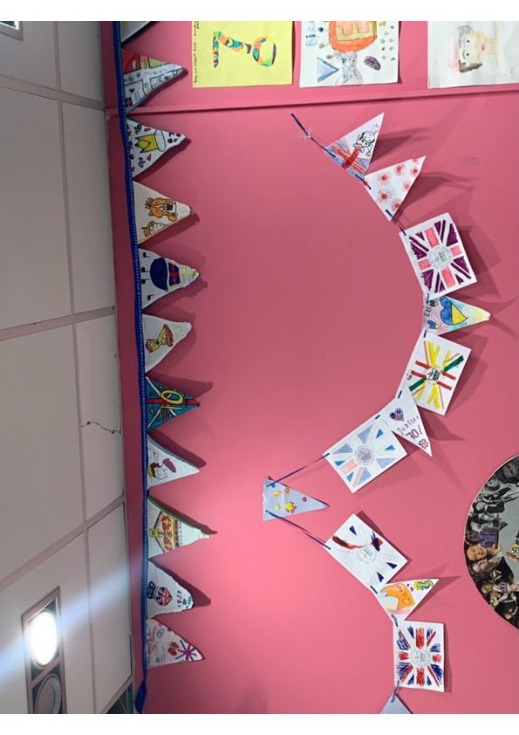
Pantomime and Nativity outside the school
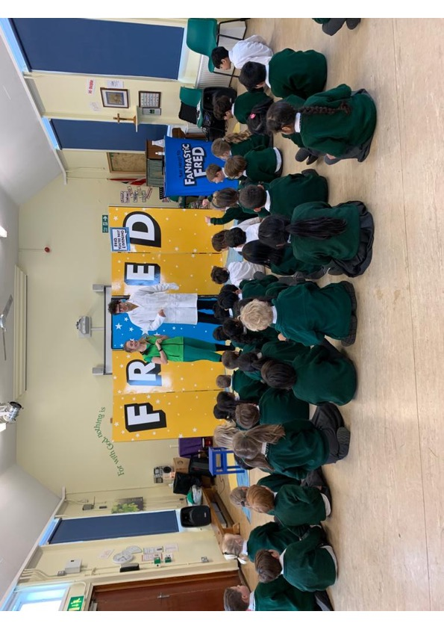
Harvest Festival filmed for parents
Whole School Forest Trips in school
Y3 & 4 trips to Ufton Court
Y2 virtual trip to Reading Museum
Hatching chickens in EYFS
Variety of charities supported incl Red Nose
Year 4 trip to Bray Lake as leaving event
Visitors to the Early Years including a Fire Engine
Windsor Sports Partnership training & in-school tournaments
Wellbeing coaching with Fantastic Fred
Y1 virtual trip Windsor Castle
Y4 trip to Longridge
Induction visits for our new parents
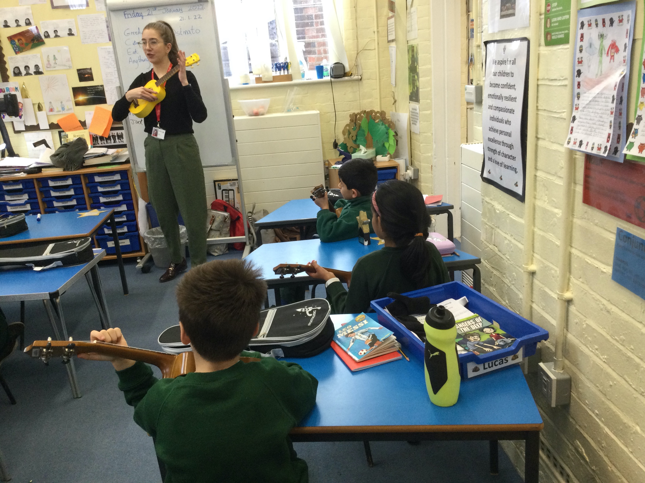
Variety our outdoor lessons using environment
Y3 learning to play the ukulele
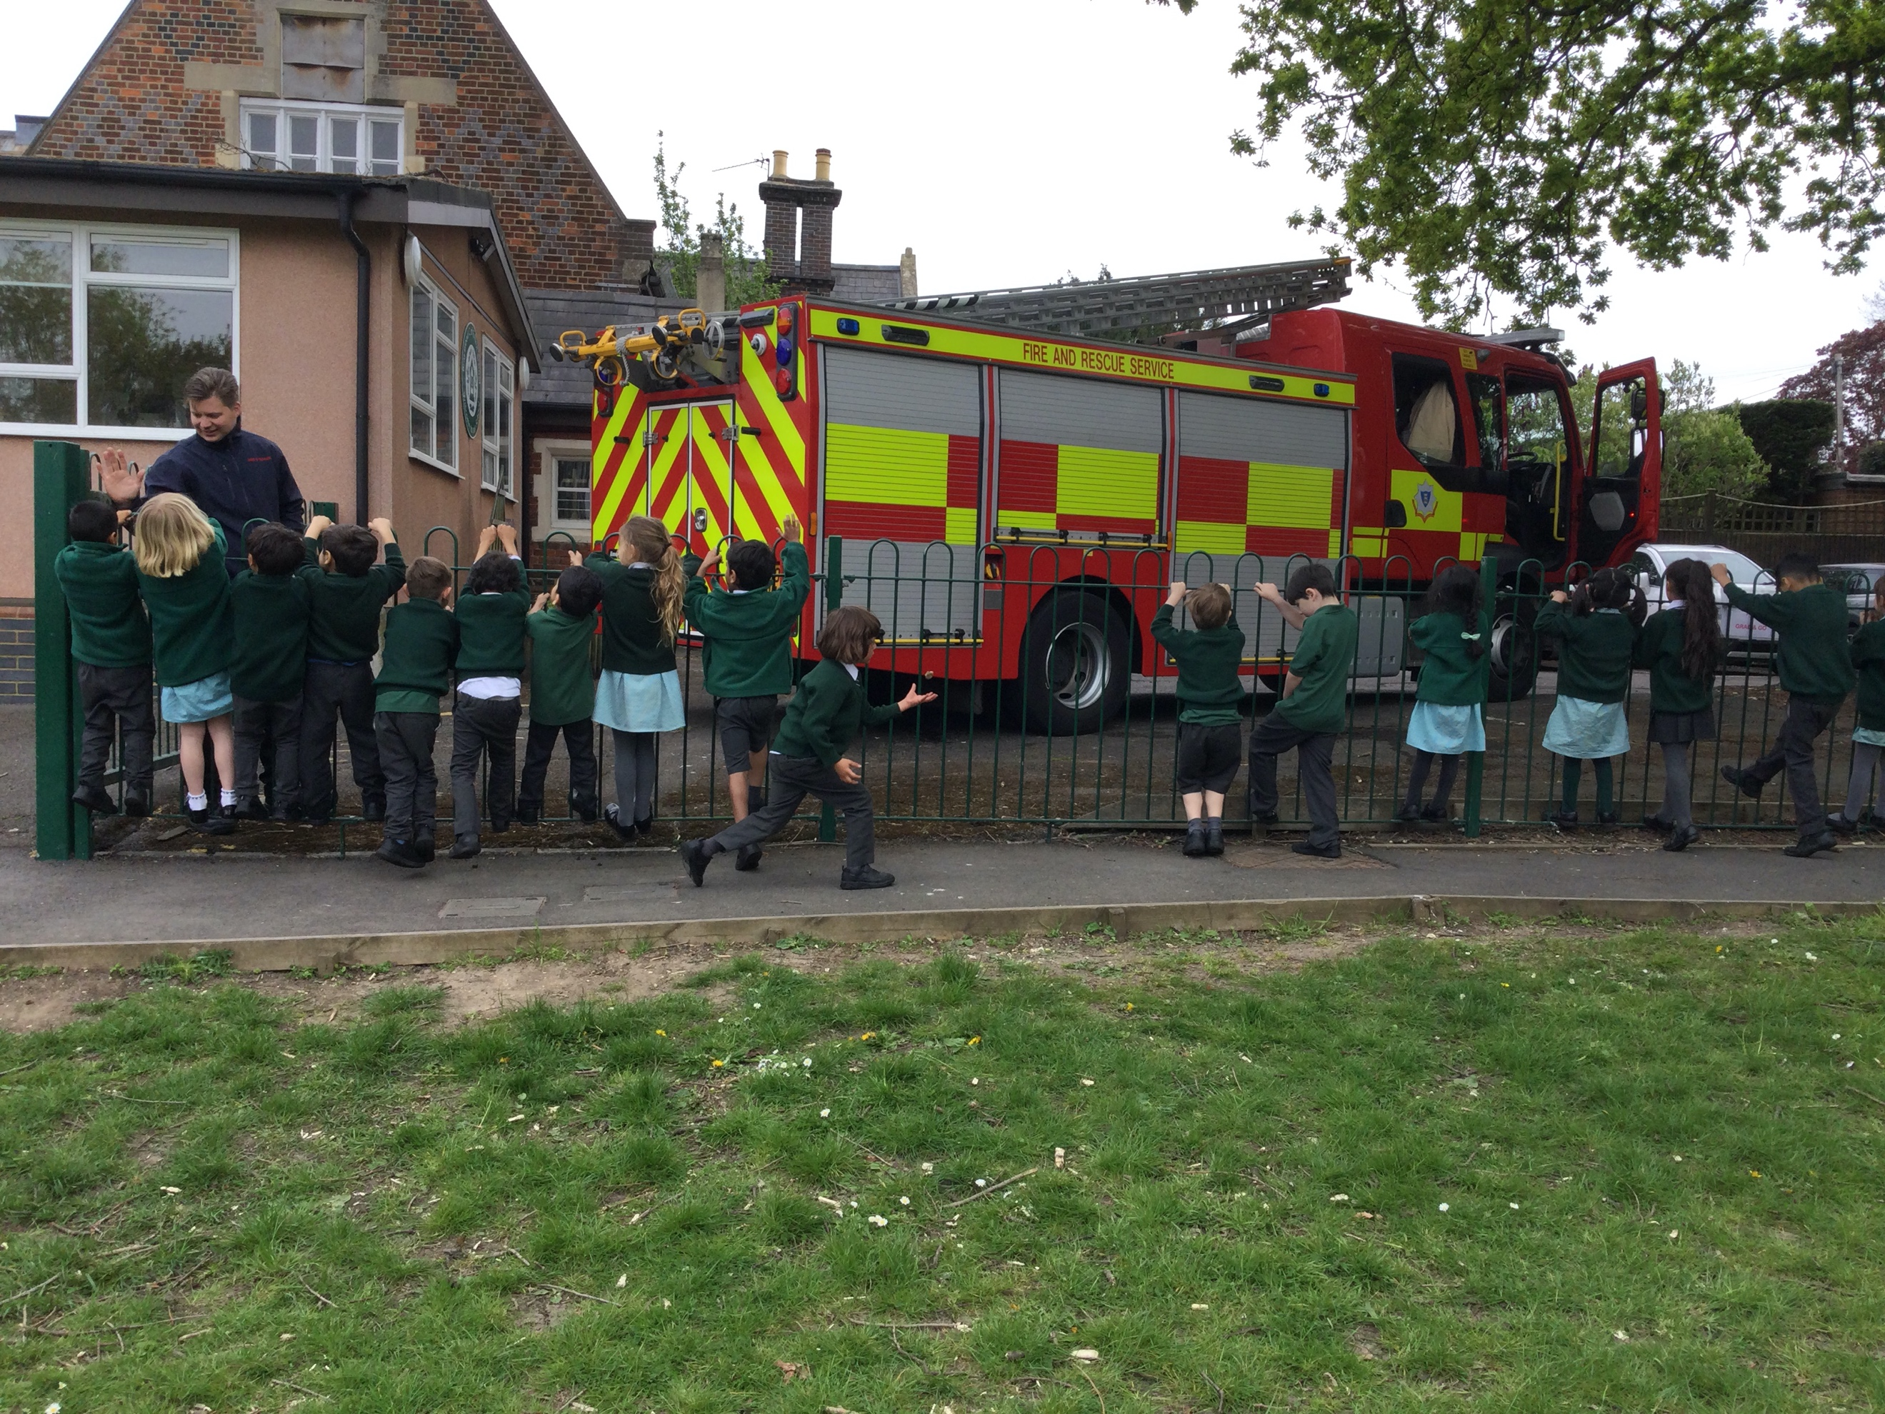
Literacy day
Maths Day
Entrepreneurial Day with Pfizer
Remembrance Service outside school
Wellbeing coaching through WSSP
Summer Concert in the Old Court
Weekly visits from Revd Ainsley on RE and Worship
Christmas events such as parties
Christingle Service together in school
Rock Steady and Piano lessons
Y4 leading Pupil Parliament, music, assemblies
Y4 running the school at the end of the year
Y1 planning a business & competitions
After school club include multi – skills club
Adapted a whole school ‘grab and go’
Parents meetings including Class meetings
Easter Concert in Church
Regular emails from teachers
Sports Day with parents
Jubilee Celebrations

Of all these activities have contributed to the breadth of our curriculum and nearly all of our usual activities have been achieved through this pandemic excepts trips outside of the school.

What are we trying to improve next year?

There are many priorities in our school development plan, but these are the key features.
- To focus on writing to support the children in this area.
- Finish the rest of the outstanding building projects including the playground.
- Set up a parent’s committee who can add their thoughts to our school improvement plan.
Who are the Governors?
The Governors are a long serving group of people who are committed to the success of our school. There are a wide variety of skills on our Governing Body from a range of sources; some are local businesses, some parents, some representing our Christian bias, and some are educationists. We are the school’s ‘critical friend’.

For more informative see our page on the website http://www.braywoodschool.co.uk/web/our_governors__1/232576

How do our governors promote school improvement this year?
The Governors work in collaboration with the Headteacher and staff, creating a closely balanced partnership to ensure that the school is run effectively. Our aim is to ensure that we provide the very best education possible.

Our staff and governors are a strong team who meet or visit school regularly to refine our improvement plan; challenge staff and ensure that our learning environment is safe and non-discriminatory. Each governor together with an associated teacher leads in one or two subject areas. The Governing Body monitors school improvement priorities through meetings, lesson visits, work analysis, policies and procedures and the financial scrutiny.

How are we working with parents?
The school and our governors value the contribution of parents, whether it is the help you give your child with their learning, the support you give the school by attending events or helping your child attend trips or events and the support your offer out PTA.

.

The governors would like to wish everyone a lovely summer break and look forward to working with you all in the new academic year.

Chair of Governors
Mrs Anne Farley

