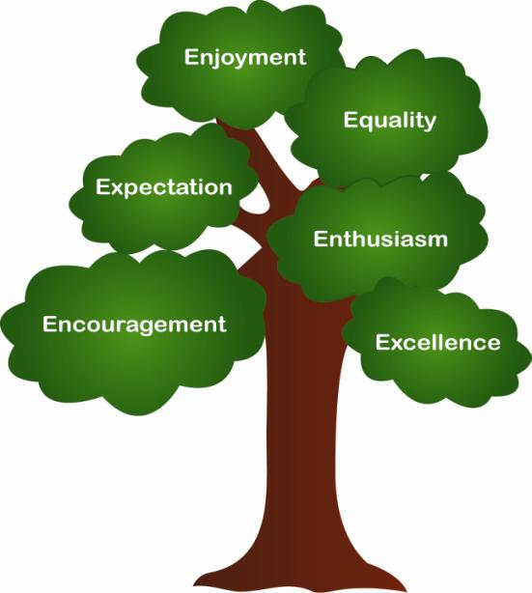
Braywood C of E First School

HOME AND SCHOOL AGREEMENT
“Through the nurturing hands of God, we aspire for all our children to become confident, secure, caring individuals who achieve personal excellence an develop a love of learning”
The School will:
- Provide a broad, balanced, creative and personalised curriculum that is fulfilling and challenging.
- Value children as individuals and encourage them to achieve their potential
- Provide a secure and caring environment, promote a healthy lifestyle and safeguards their needs.
- Encourage the children to take care of their surroundings and others around them.
- Provide a clear framework for behaviour management and encourages pupils to make the right choices. Give early warnings of any problems concerning work, behaviour or relationships.
- Regularly inform parents of their children’s academic/social progress and has a clear homework task
- Keep parents informed / involved in all aspects of school life.
- Provides a range of extra-curricular activities
Our families will:
- Takes an active interest in their child’s education and encourages their child to do their best
- Ensures that the child attends school regularly, on time and in correct school uniform.
- Let the school know if there are any concerns/problems that might affect a child’s work or behaviour.
- Support the school’s approaches and guidelines for behaviour and standards.
- Support their child in reading, homework and other opportunities for home learning.
- Encourage their child to take a pride in their school and play a full part in school activities
- Act as a responsible digital role model and use social media appropriately and courteously
- Safeguard our community’s data – don’t share photos or digital information on social media
- Attend parent evenings and discussions about their child’s progress.
- Wherever possible, participate in all aspects of school life.
The Child will:
- Adhere to the School Charter and respect the rights of others without exception.
- Do their best and show a positive attitude to learning
- Follow the behaviours for leaning
- Complete their homework on time and to the best of their ability.
- Be responsible for their belongings and help to keep their classroom tidy.
- Come to school dressed smartly in their school uniform.
- Always be polite towards adults and peers at school and to respect your parents at home.
- Exercise self-discipline and take responsibility for their actions in the real world and the online world
- Ensure that they get to school on time with everything you need for the school day.
“All children need a positive and supportive partnership between home and school. Working together, we will achieve the very best for our children in an atmosphere of happiness, security and trust.

