ESchools Pupil Portal
Web address - braywood-ce.eschools.co.uk/login
Log in is via a pictorial password.
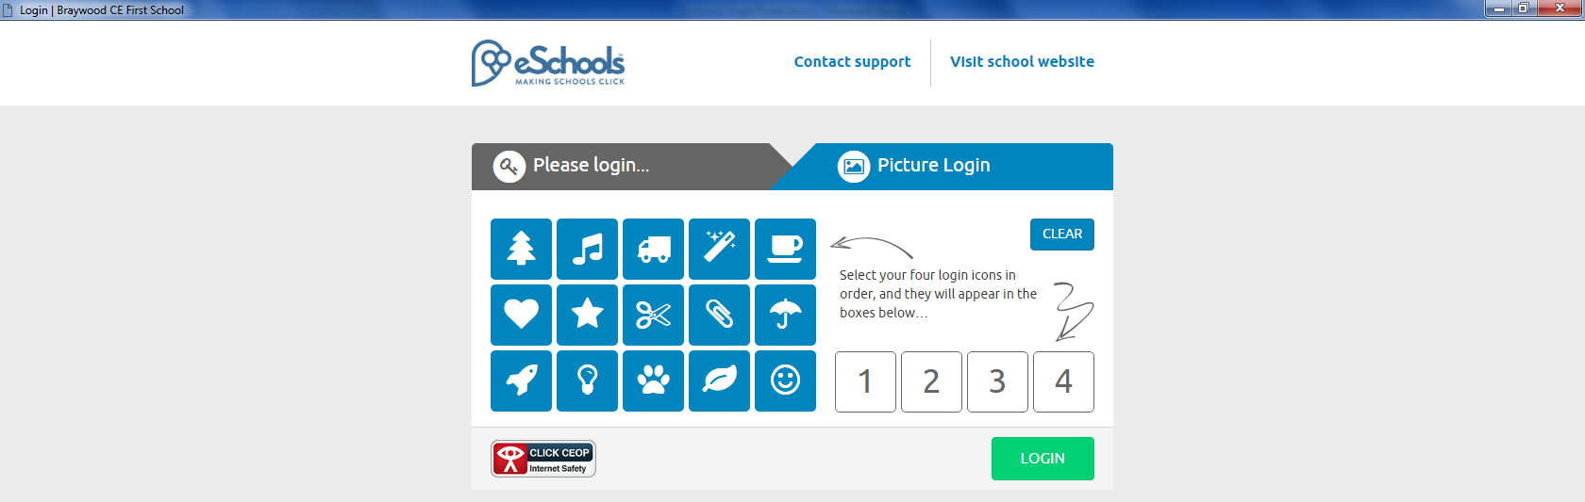
Click on Login button
Need to click on picture log in tab.
Click on Login button
Choose your first initial by clicking on letter
Eg if called Kate choose a K
Click on Login button
This will allow you access to eSchool

Choose your second initial by clicking on letter
Eg if your surname is Hall choose an H

First page is called ME

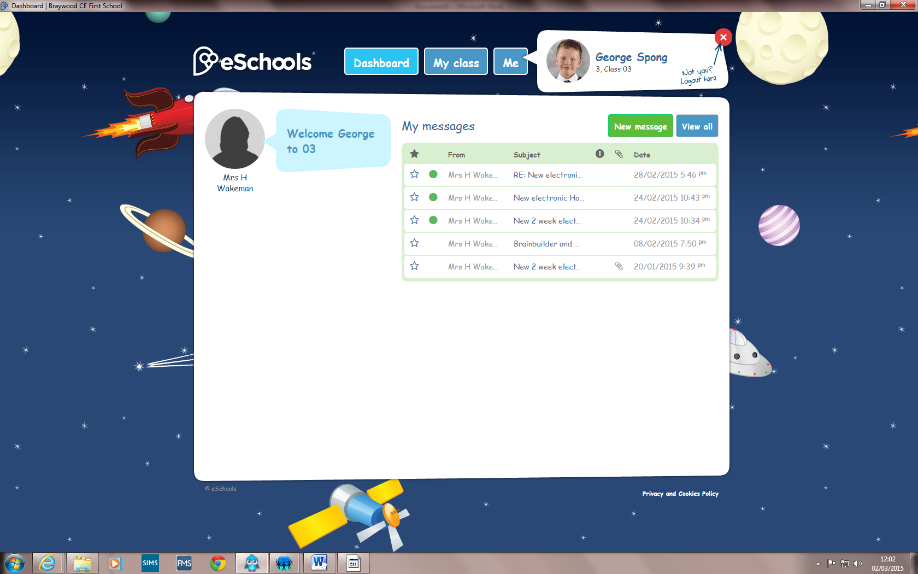
And this one MY CLASS
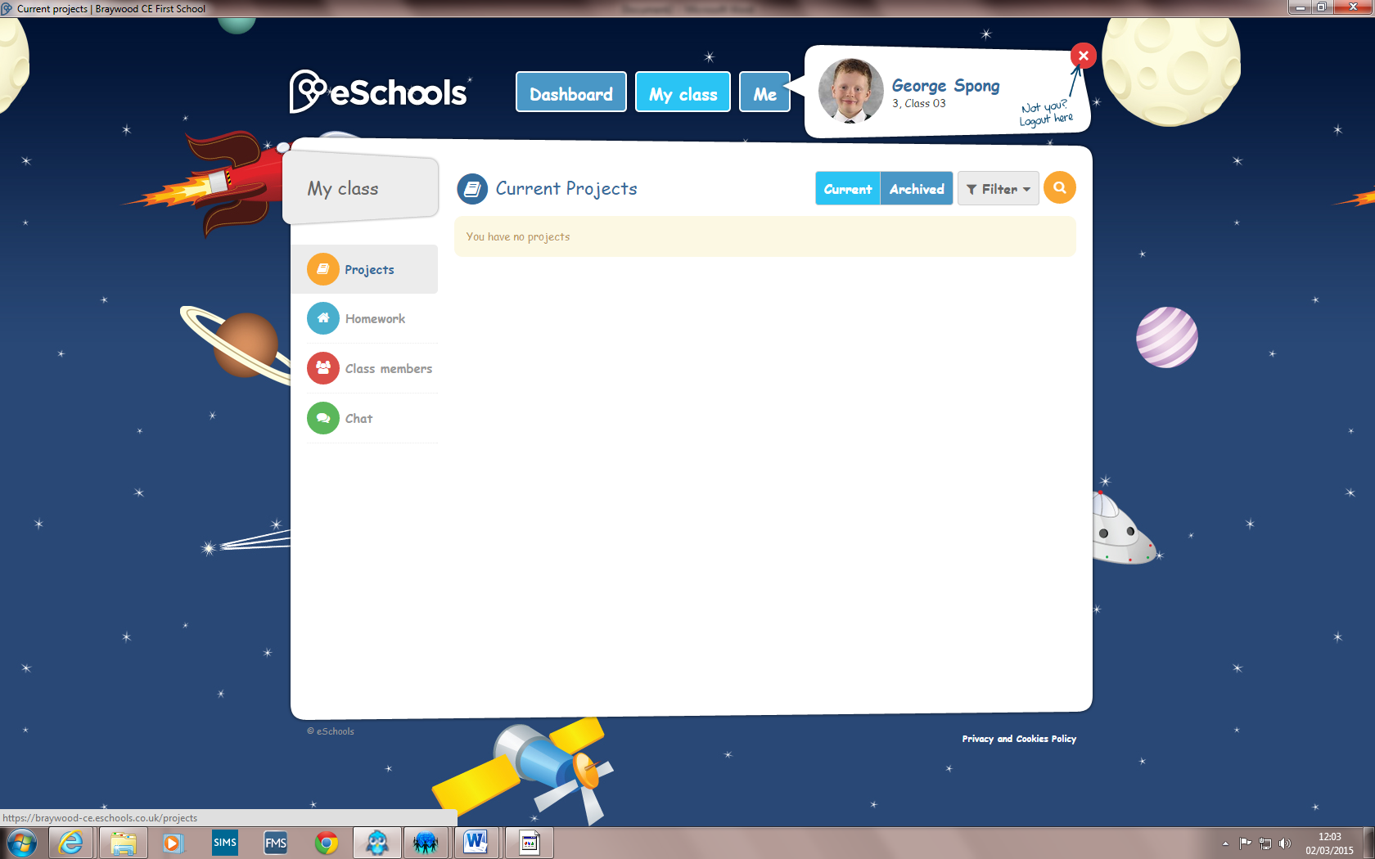
Click on these to access projects, homework and other information.

